Savant Competitive Survey D. Wong draft 12.30.13
Business Case
Savant’s core business focuses primarily on dealers and manufacturers, premium-tier consumers and businesses. In 2014, however, the company is planning to pivot towards one that also accommodates middle/middle-upper level customers, and direct sales to consumer as an option as well. To better manage a broadened market expansion and support increasingly-dynamic marketing and sales initiatives, the Web site will see a series of rolling enhancements to meet these future needs.

The existing Savant site while informative, broad, and representative of the brand is reaching its end of life cycle in regard to these new strategic goals. The current site focus on products, and to a lesser extent lifestyles, then consumers. It’s increasingly difficult and costly to modify because its built and maintained by an outside agency, and the design style, and technology back-end is starting to feel dated when compared to top competitor offerings.

Updates will seek to extend the brand to make it accessible to all strata of buyers (dealers AND consumers at varying levels) and sales channels (e.g. resellers), giving Savant’s dealer network access to self-service (Ex. eComm platform early 2014), and consumers enhanced fulfillment options (e.g. “do-it-yourself” (DIY) options). Marketing and positioning of product and messaging, staging it from a CMS, and bringing the site experience forward in terms of its underlying technology and design, are also on tap in the year ahead.

Overview
This document serves as a preliminary design review of Savant’s top tier competitors as a means of informing design decisions as we seek to revamp Savant’s site UX. To those ends, design review focused on Control4, Crestron, AMX, Lutron, as well as Nest, qualifying as a “site we like” (Nest) as it speaks to 2014 objectives. Focuses of this review included a qualitative look at:
- Overall UX design execution. What’s being done well, not so well, and how it applies to us.
- Assessment of the look-n-feel, layout, content, general structure, and styles applied from both an aesthetic and UX strategic POV.

Executive Summary & Recommendations
Overall, Savant’s site fits at the upper end of a short spectrum led by Control4, then Nest, and finally Lutron. These sites in essence exemplify what we want to do and where we want to go in a new site while Crestron and AMX, personify where we don’t want to go.

Differentiation varies for the leaders in our space but at the heart of it, these sites share a number of similarities, as well as specific features and attributes, that we should consider as we look ahead to enhance our online persona. Among the commonalities these sites:

- Start a human conversation about the value proposition to end-users, and lesser so about the product. From Control4 to Nest to Lutron, the sites talk about what it Means (WIM), the bottom line benefits in real terms using real consumer stories in many cases to humanize the product and put it in a real-world context. It’s still about lifestyle but from a viewpoint of the people that live them, and then it’s about the product offerings that make their lives better.

- Spend time upfront educating users and building trust. Common to these sites is a focus on educating conversationally, and without sounding pedantic. The content is engaging and informative, takes a personal tone and builds natural curiosity and interest that in turn, drives desirable exploratory and discovery behaviors. They also build up a user’s trust and put requests in context before asking for a user’s personal information. These sites still talk about who they are, what they do, but tend to talk about why they do what we do and connect it to their audience’s wants and needs, their imaginations (e.g. Possibilities) as well as real-world concerns (e.g. Energy savings, remote security, peace-of-mind). They also are conservative about where and when they ask a user to reach out, and provide multiple methods (forums, email, AND phone numbers) to connect with the company. No one seemed to be offering chat or concierge functionality.
- Employ an array of passive and active techniques to engage users. Video demos, demos that are interactive (some of which auto-play, others requiring manual opting-in), and in-page displays that demonstrate the “power” of the product from beginning to end, (Lutron’s lightswitch calculates cost and energy savings on-the-fly while a user toggles it), capture attention without being heavy-handed in the selling process. In this way the brochureware sites engage users at a level beyond that of traditional push marketing or print advertising can.

- Design towards current trends in UX and Web dev. These sites feel “out-of-the-box” in that some make good use of horizontal as well as vertical space in their dimensionality; They tend towards the trend of flat design and modern takes on “one page” designs; They make use of full-width, crisp and compelling photo art/vector imagery and iconography; They employ some of the latest design styling for the Web, making use of progressive disclosure (e.g. hidden panes that side open or down as they become relevant to the user’s stage within an area), and elegant design (e.g. Using javascript to enable smooth transitions/animations and easing effects while navigating or experiencing the site).
- Content is indeed still the king. Copy is succinct, compelling, interesting, witty, and direct, and spoken with a consistent voice and it shows. Taking care to drive copy professionally sets an overall attitude and tone for the design and experience. Use of direct bottom-line language, and a non-technical “laymen’s” vs. engineer’s approach that speaks to anyone enables them to reach a variety of consumers without being caught in jargon or division.

Specific Site Reviews: Control4, Crestron, Lutron, AMX, Nest

1. Control4 http://www.control4.com
“Home Automation and Smart Home Control”
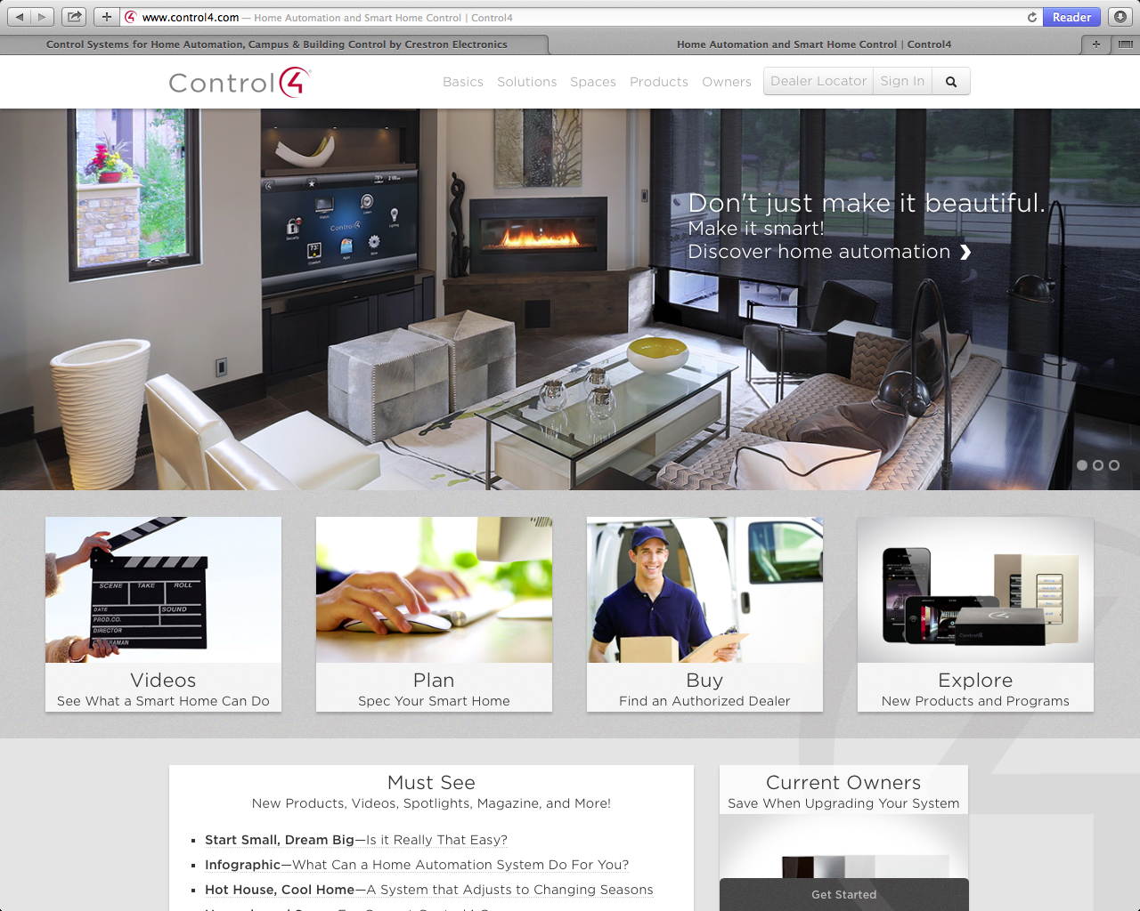
Primary: Don’t just make it beautiful. Make it smart!
CTA: Discover home automation
Secondary: Fewer components, more entertainment!
Watch and listen to everything, anywhere in the house

General Observations
Our #1 competitor ‘s site is lifestyle-focused. The site does a good job of building trust, and giving visitors more than it wants. There appears to be an intentional effort to avoid blatant top-level lead requests for user information (conversion) until there is enough trust and context around such a request. There appears to be an intentional effort to pitching the site from a “solutions” perspective, and Control4 is consistent in talking about its products always within the context of the people. Content is ample, balanced, and verbose within limits to not overwhelm a reader. There’s an implicit focus on the users wants and needs. Content also meets users where they lie varied levels of buying. Other thoughts:

- The site is iPad optimized, fixed-width responsive 1024w, but not mobile enabled.
- The overall design choices to use semi-transparencies, a muted yet vibrant aesthetic that pops because of the use of original and /or high-quality stock imagery, measured typography, and good color choices conveys high quality.
- It’s still brochureware but the site succeeds in not sounding like marketese boilerplate. The overall tone is personal, friendly, put-together, confident, and not preachy, productized, marketed.
- There’s no commerce, self-service option for consumers or dealers, and the site is not mobile scalable (Note: The blog is responsive)
- Persistent branding in the header and persistent contact form in the footer (See the“Get Started” form toggles open when clicked)
Content
- Good organization of content by audience type, stage/life-cycle, cross-category and grouping
- Good breakdown of content that speaks to cross audience - consumer, integrator, dealer, designer, etc.
- Humanized throughout with real case examples, people vs. pics and details about “black boxes”
- Social media sharing, wrapped in one page vs. ubiquitous across the site; Blog looks like a custom Wordpress design that is unique in layout, is responsive to mobile (rescales when resized) and appears fresh and current.
- Robust showcase case examples showing market depth and range US and EU
Design
- Good use of horizontal space (Ex. content and gallery carousels are embedded within long-form pages); Measured use of vertical space -- Pages can be long but not overloaded with content.
- Use of premium stock and/or original photography appears designed and consistent vs. slapped together.
- Words that come to mind: Clean, modern, flat, crispy, classy, muted texture
- Clean typography, effective use of typographical styles, white space, however, the contrast of type to backgrounds could be difficult for some older readers with eyesight concerns.
- Technology-wise good the site makes good use of easing effects, transparency/opacity effects, transitions
- Design overall appears to be “flat-hybrid” in that layering effects, transparency, opacity do well to convey brand and messaging and lending itself to the subtle and classy; Like an app unto itself.
Takeaways (Strengths/Weaknesses)
1. Control4 does a good job with Navigation structure and maintaining the user’s orientation. IA Navigation groupings are organized and clear (nothing appears “stuffed in” simplified navigation structure aids user orientation, and labels are adverb/action-oriented (v. categorically) oriented.
- Clear separation between consumer and dealer and partner sites at a macro IA level
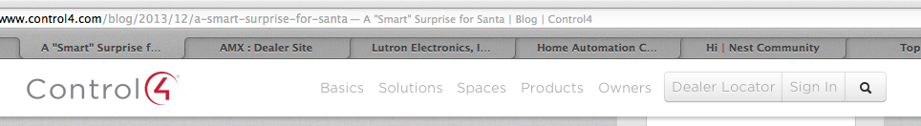
- Good short labeling, room for horizontal extensibility, visual styling supports user orientation
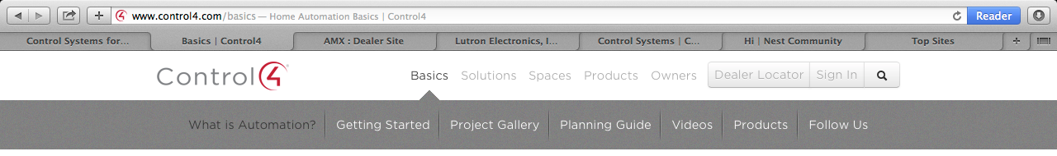
- Simplified categorization and sub-categorization helps support the user’s mental model
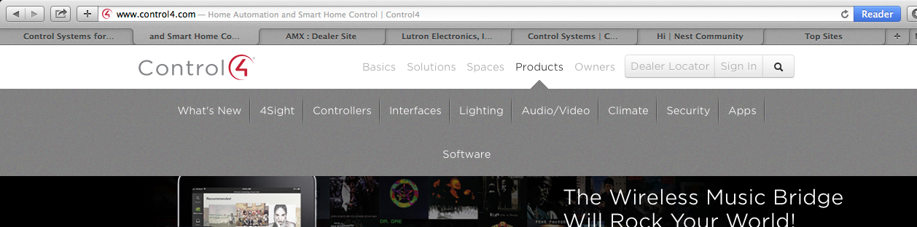
2. Control4’s design uses images vs. text to drive consumption, and there’s a big emphasis on educating visitors. There’s an implicit educational focus on the consumer side that drives browsing behavior, and a variety of options to explore by clicking on imagery, reading short vignettes, or watching a video.
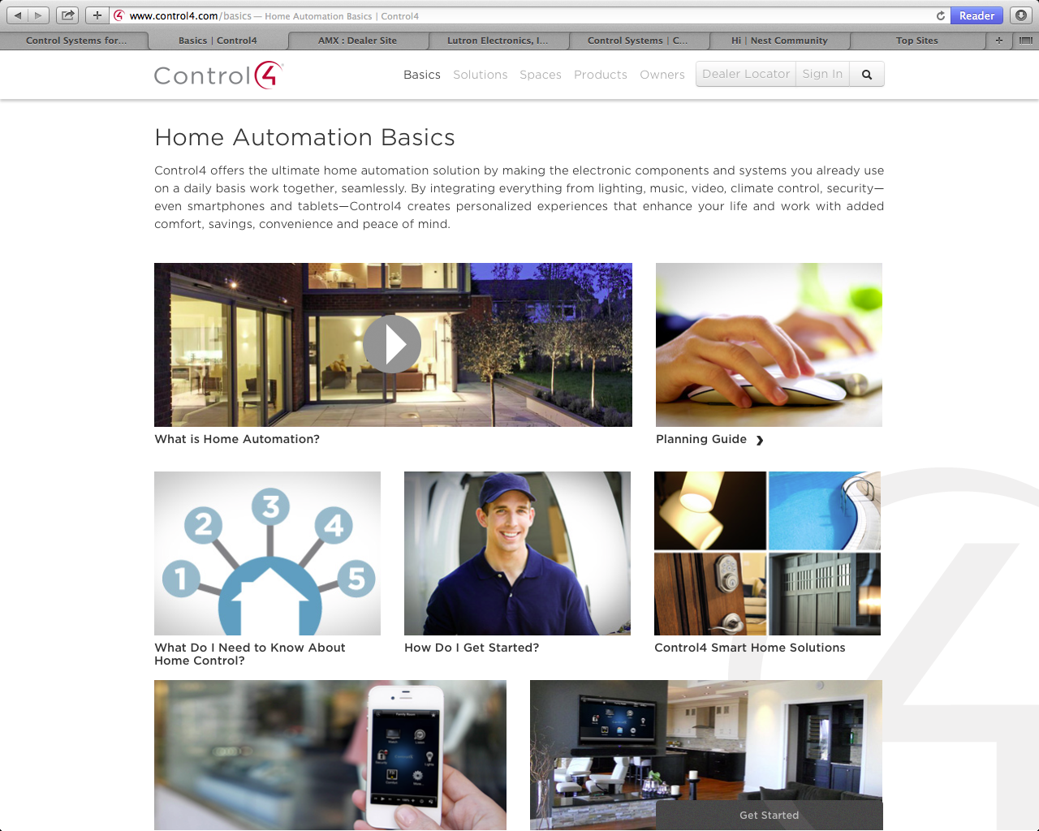

3. Control4 makes effective use of adverb and action-oriented vs. categorical subheaders to organization content. We should seek to organize content logically and with best practice phrasing.
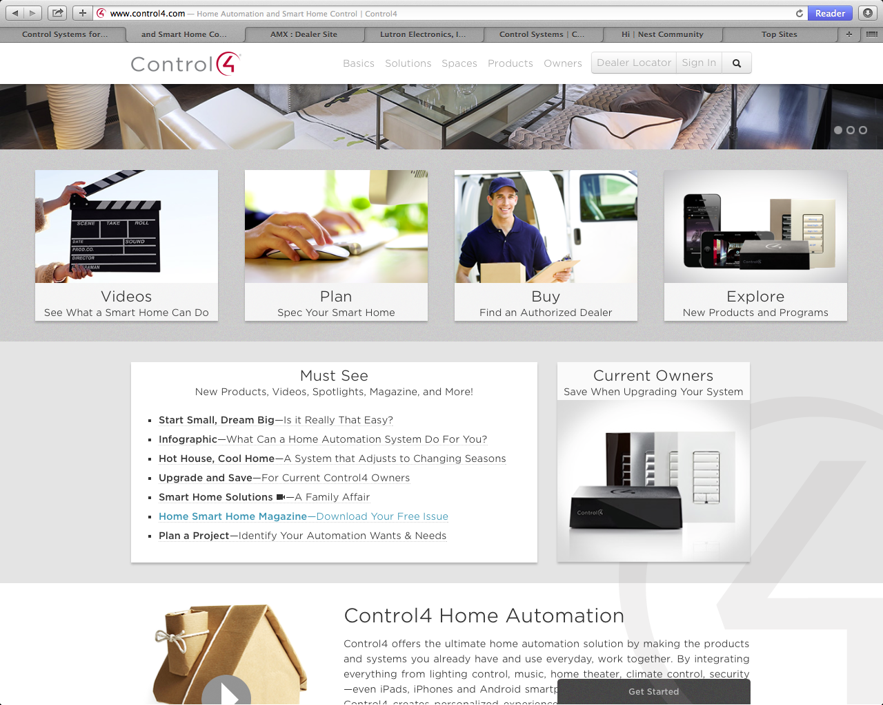

4. Control4’s design emphasizes “progressive disclosure” vs. more pages. Whether its clicking a link that folds down a hidden pane, playing a video that runs in-line embedded (vs. launching a modal or native player), the site’s architecture lets the user decide what and when to get more involved, and maintains the user’s task focus seamlessly.
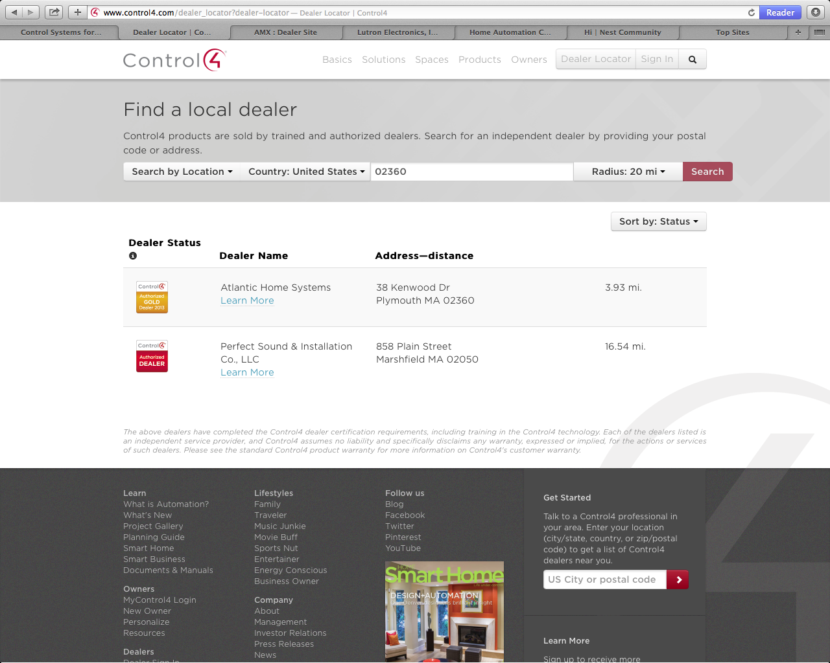

Before and after playing the video for “Control3 Home Automation” on the Basics page.
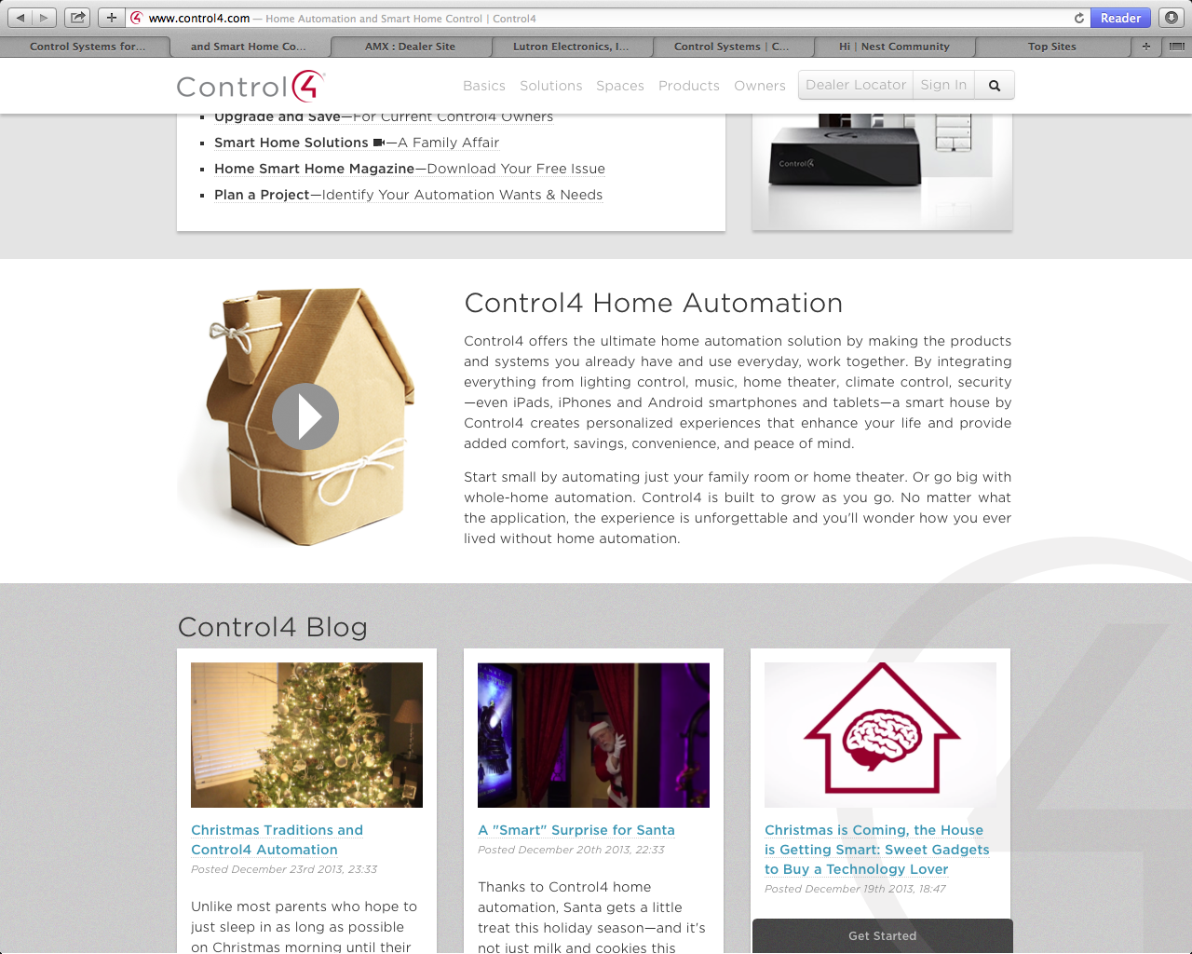
Video plays in-line in the page as a modal frame; the page is still scrollable vs. locked to view. We want to focus the user but not lock them into anything if they want to leave while browsing.
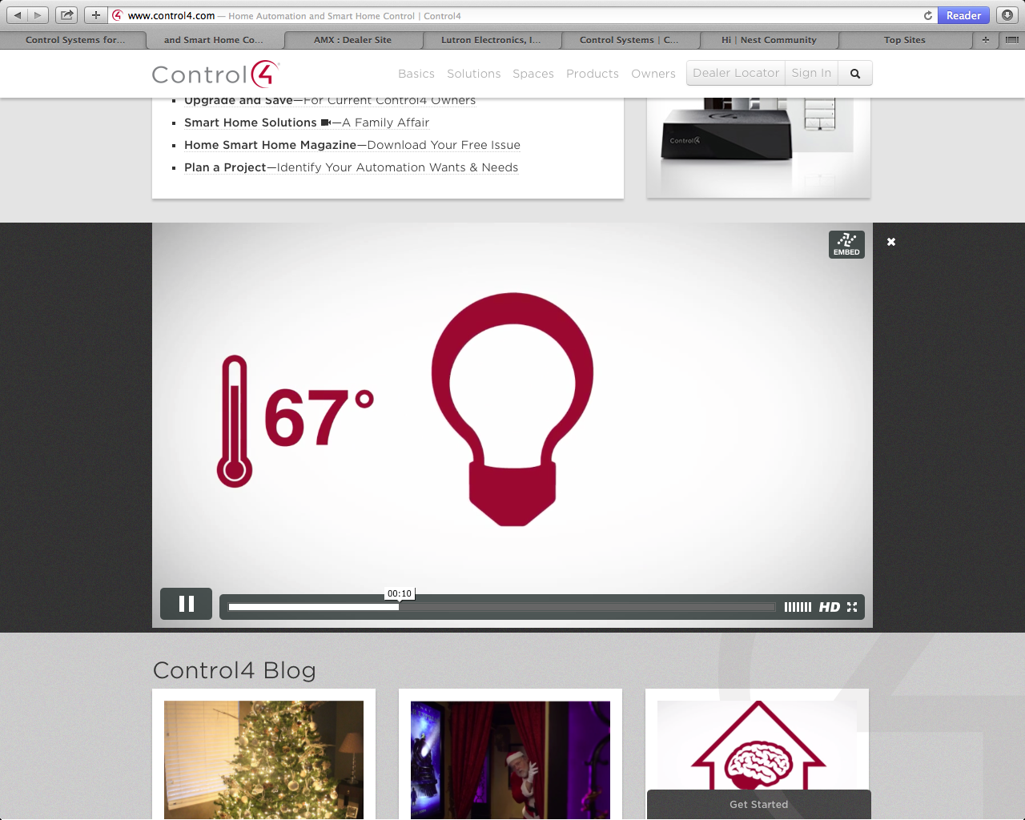

5. Control4 dealers are given prestige and promotional footings in the site. The site permits transparency to their dealer network, and the dealers in term get cross-promotional opportunities on the site via a directory. The directory acts as a cross-market opportunity that spells cross-SEO benefits to the company and its dealers.
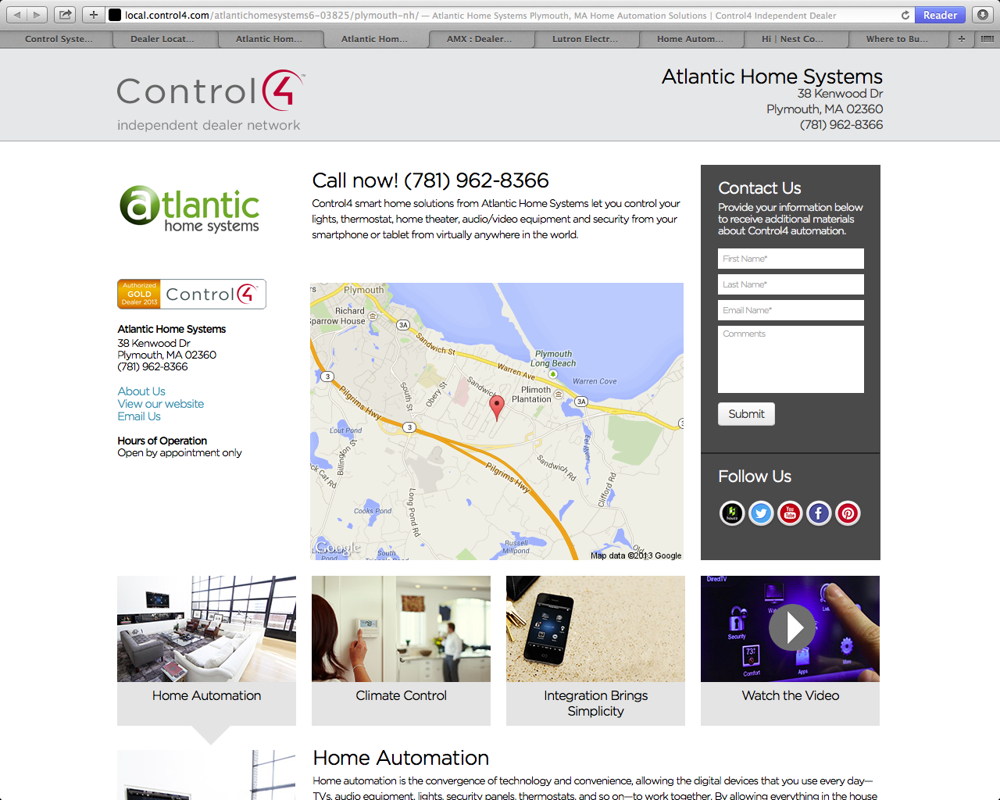

6. Control4 has an extensive case study gallery that clearly demonstrates its product/market segment, range, and depth.
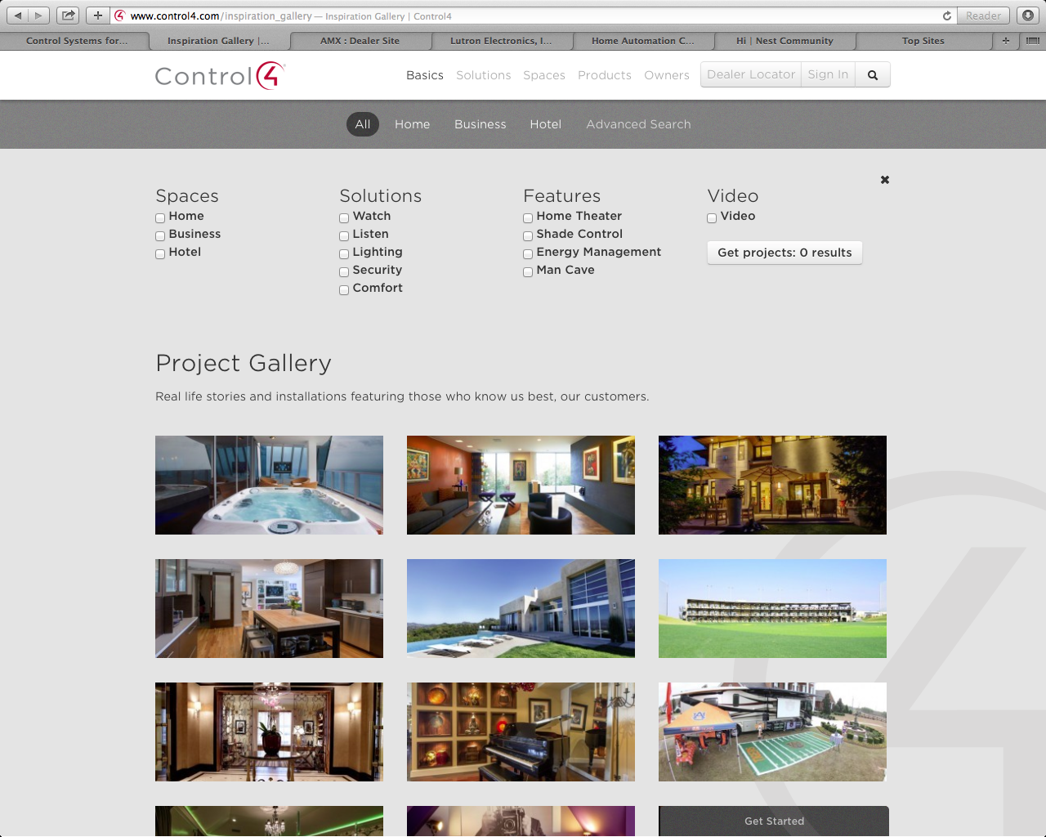
7. Bold use of full-screen imagery follows current trends. This one is clearly stock art but we should consider when feasible to utilize bold, full-width imagery that is a current design trend.
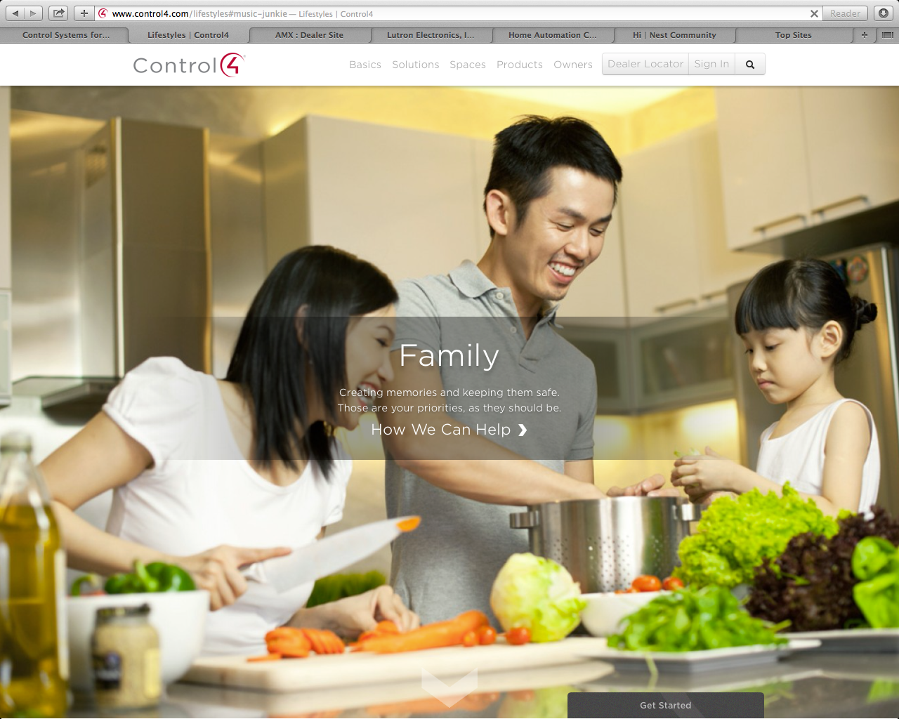

Crestron http://www.crestron.com
“Control Systems for Home Automation,
Campus & Building Control by Crestron Electronics”
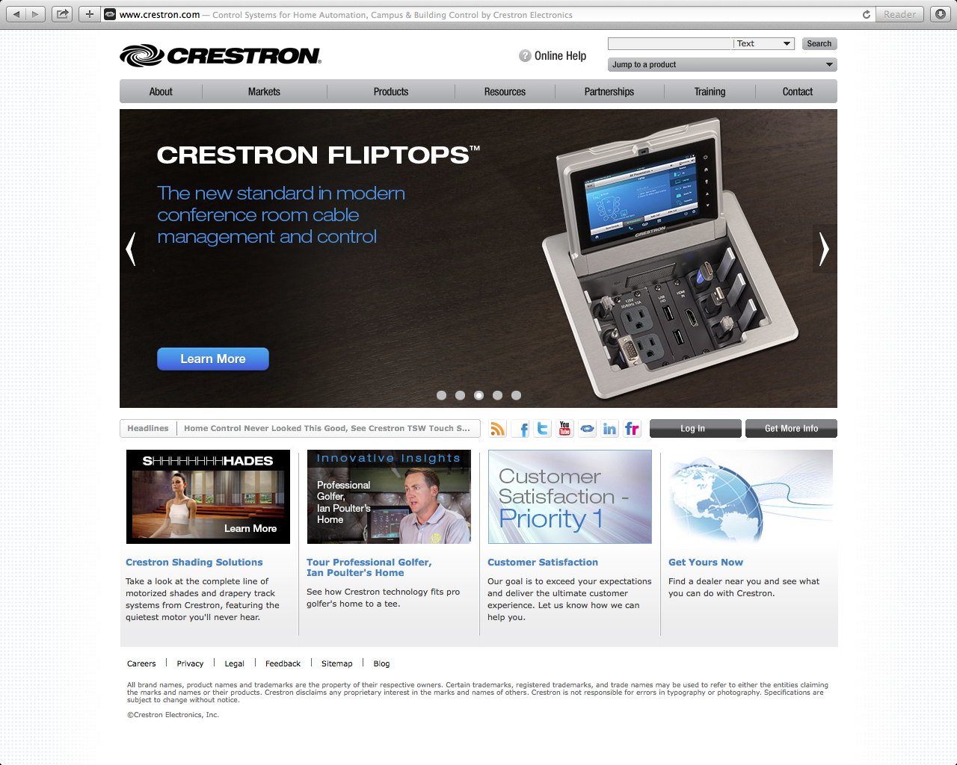

Primary: The leading provider of control and automation systems
Secondary: Take control of your home from any seat in the house
CTA: Learn more

General Observations
Crestron markets mostly to dealer, manufacturer, partner audience, as evidenced by its focus on product model numbers, photos of boxes, switches, and wiring, etc. The site’s general feel is headed towards antiquated as evinced by the overall pitch and tone of content on the site, and the general (lack of) attitude and/or visual design. While not the worst of the bunch, the site lacks the professional polish one might expect for a maker of high-end home and commercial automation products. Some general notes:

- The site is fixed-width 975w, center-aligned viewable site white on white background
- Typography is small to approaching illegible whether it’s in the body, navigation menus, or rendered image graphics.
- The site lacks a cohesive smoothness of structure, navigation expected for our market.
- Instead of landing pages with content and navigation, many 2nd level top landing pages only feature a left-hand nav/”tree” directory which seems weak and unimaginative (e.g. About)
- Graphics appear antiquated, crunchy, and taken from low-quality stock while many are clearly custom images that are also lacking in quality.
Content
Crestron’s content is non-remarkable in terms of offering, tone, and attitude. This is uniformly so whether it’s found in body copy, a video tour, or in an interactive demo. The copy is non-professional, and fluffy, and reads like filler. If there’s one thing the site is doing consistently is providing basic information about the product offering, in as bland, and unexciting terms as possible. For example, “Crestron Home Automation: The total package. When it comes to your home and your life, you don't settle for anything but the very best. You want everything to be complete, easy and worry-free. That's what a true home automation solution should be, and that's what you get with Crestron.” A quick rewrite saying the same thing: “Why Crestron Home Automation? It’s easy and worry-free. Don’t settle for less, go forward with Crestron for the very best when it comes to your life and home.”

Design
Crestron’s design styling, color and typography read as “safe” choices. There are lots of whites, neutrals, grays seem indicative of the bland mood of the overall site design. Much of the site is rendered in older Web standards meaning there’s a lot of rendered imagery for buttons, banners, subheadings, and teases. Crestron’s site has none of the transitioning, easing effects, or polish expected for the type of product being offered. It’s clear from the lack of imagination on the site that it’s either very old, lacks the resources to maintain, enhance or update, or there’s no wherewithal to advance the design. There’s consistency but it’s not terribly cohesiveness or compelling.
Takeaways - Strengths/Weaknesses
1. Crestron has some interactive options but they are buried deep in the experience. In the Enterprise Markets, there’s an interactive video that enables users to “drive” and get a simulated automation experience. But it’s clunky and lacks a voiceover “tour” but enables some interactivity.
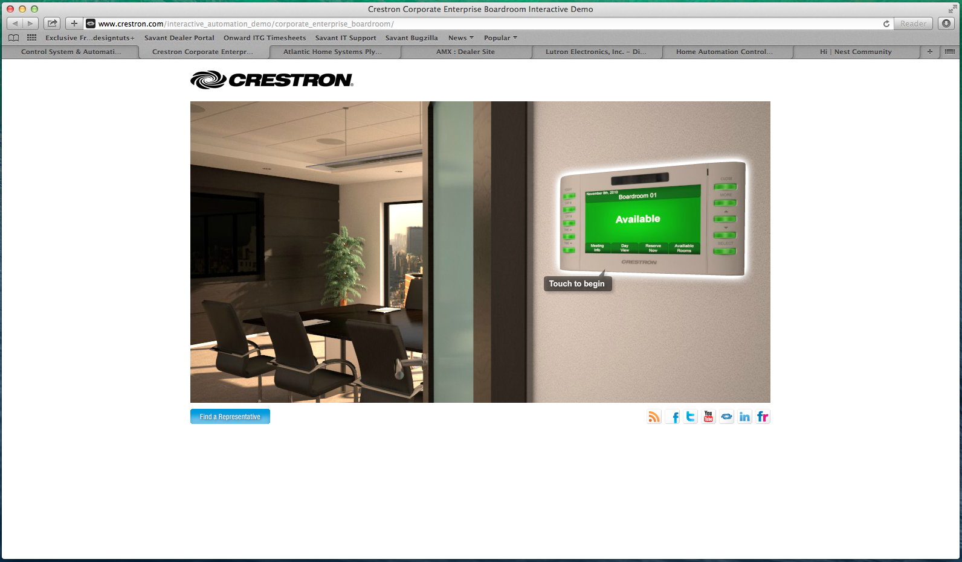

2. Technology being used on the site feels antiquated. The site uses older models of interaction that feel like someone only half-cared to implement them. The cardinal rule for such features is if you’re going to do it, do it well, make it cool, and never crammed and clunky.
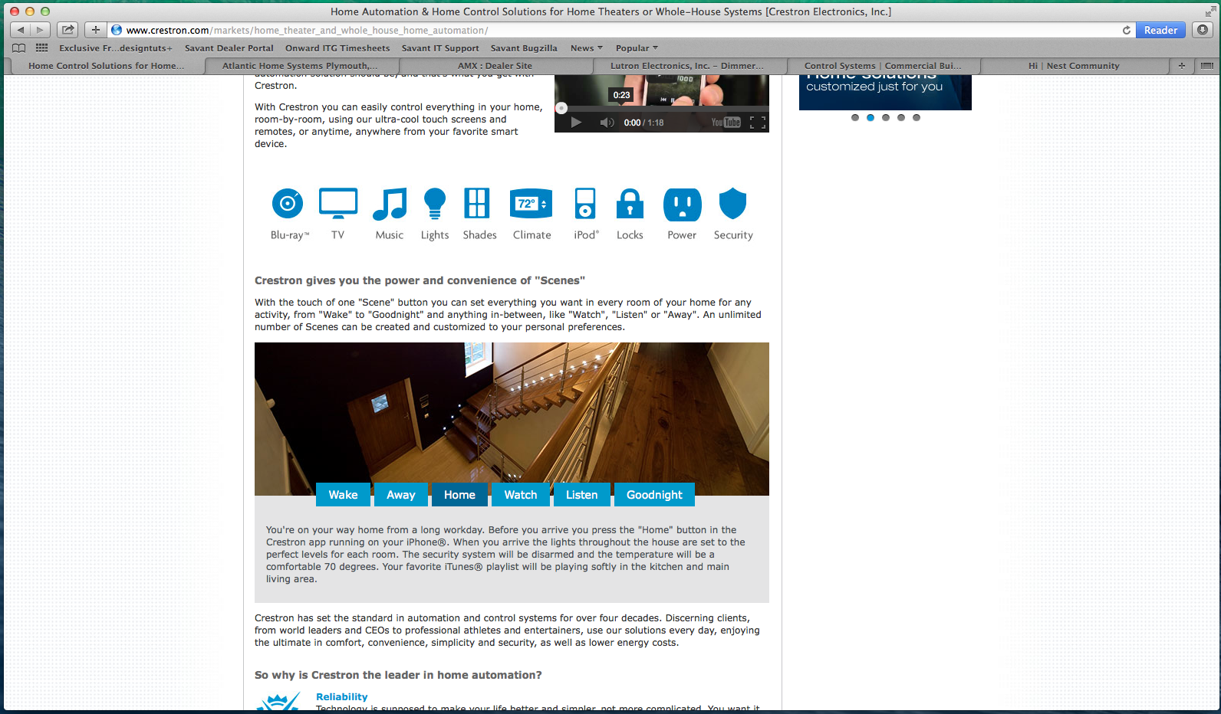
3. Long forms, bad graphics. Long form contact methods and searches, as well as kitsch graphics in subheadings are things we want to avoid. Usage only makes it feel that much more templated, old, and dated. More lack of polish around imagery and site design: Many rounded corners on nav, buttons aren’t rounded properly, and gradients look grainy, low-res, and are rendered vs. CSS-driven.
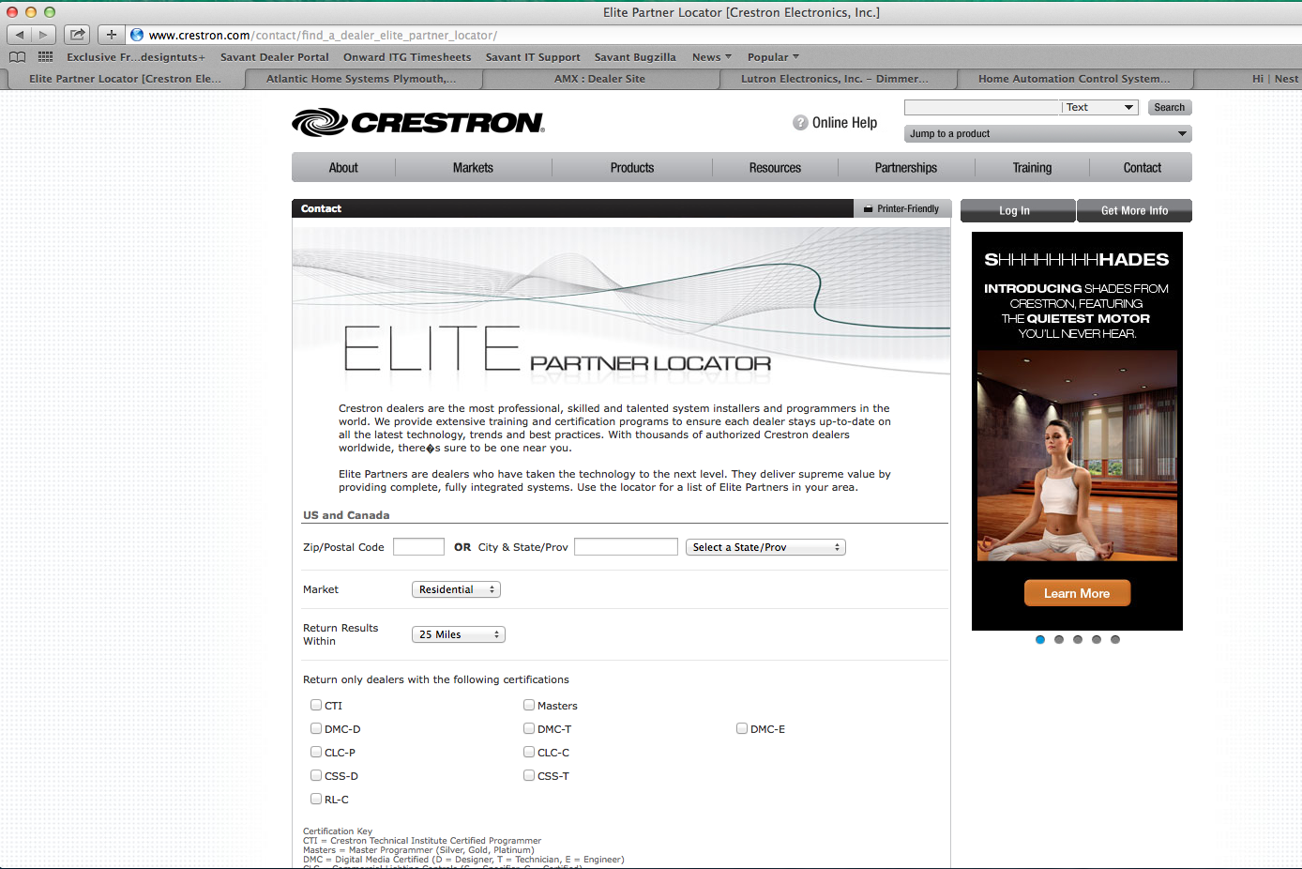

4. Typography is non-uniform, inconsistently applied, and small. Ex., the many “mega-menu” navs that pull down from the primary navigation bar. The menus open with an abrupt lack of transitions, snapping open/closed abruptly.
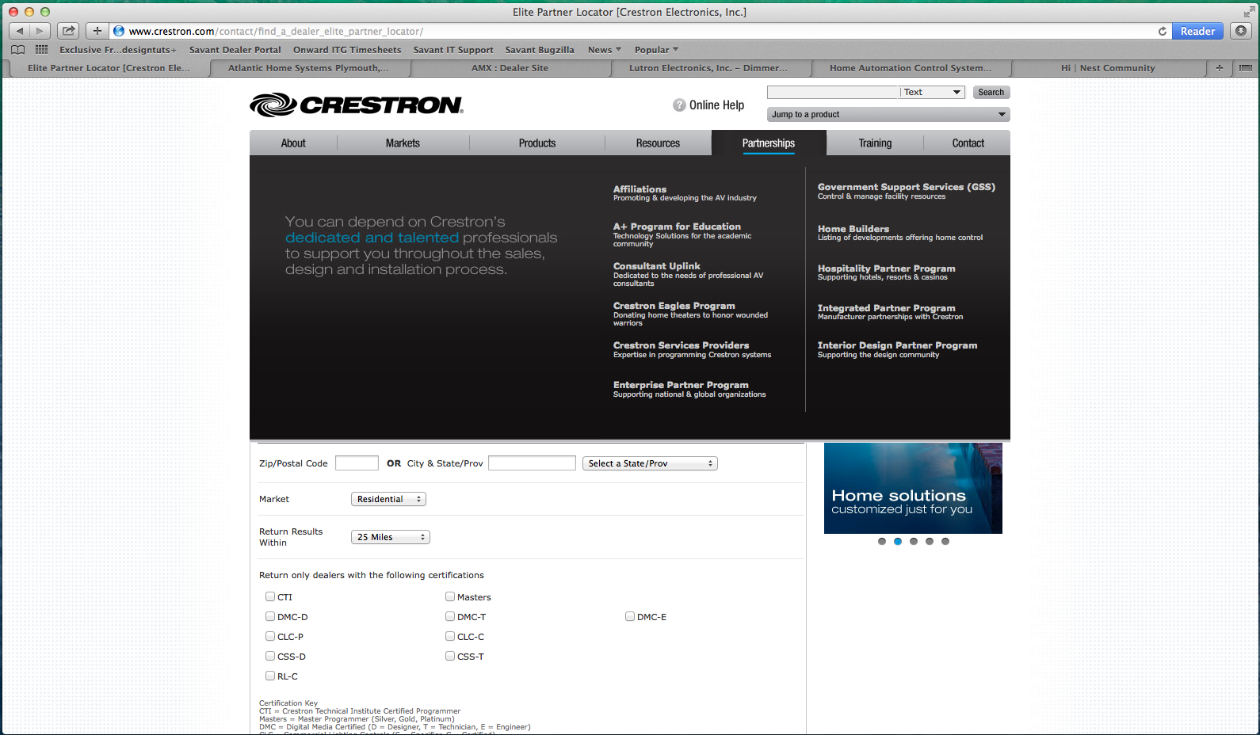

5. No landing pages, and cryptic language. Content for Crestron’s Unversity landing page is just a directory tree, and the product menu is a cryptic list of model numbers without the aid of proper sub-groupings, organization, or laymen’s language.
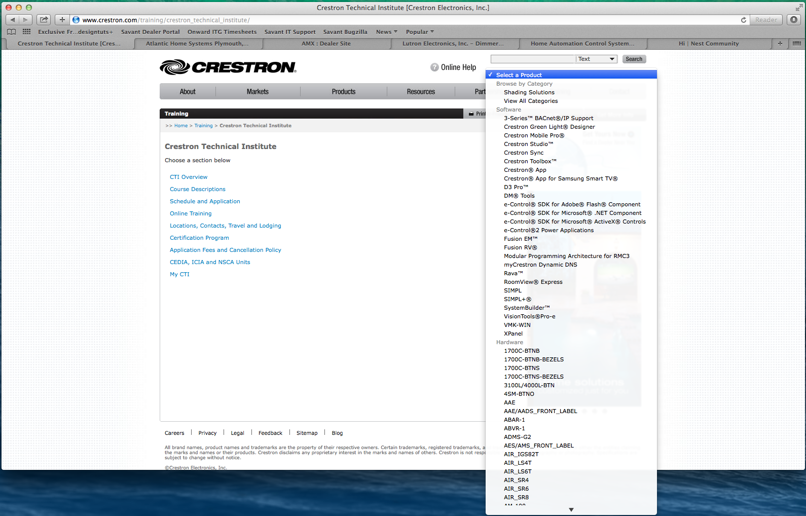

6. Use of low-quality stock imagery, old school button/nav styling. More old imagery, and the use of black, white and gray colors seem unimaginative and lacking in creativity. The advertising space in the right column promotes house ads to lower-level sections.
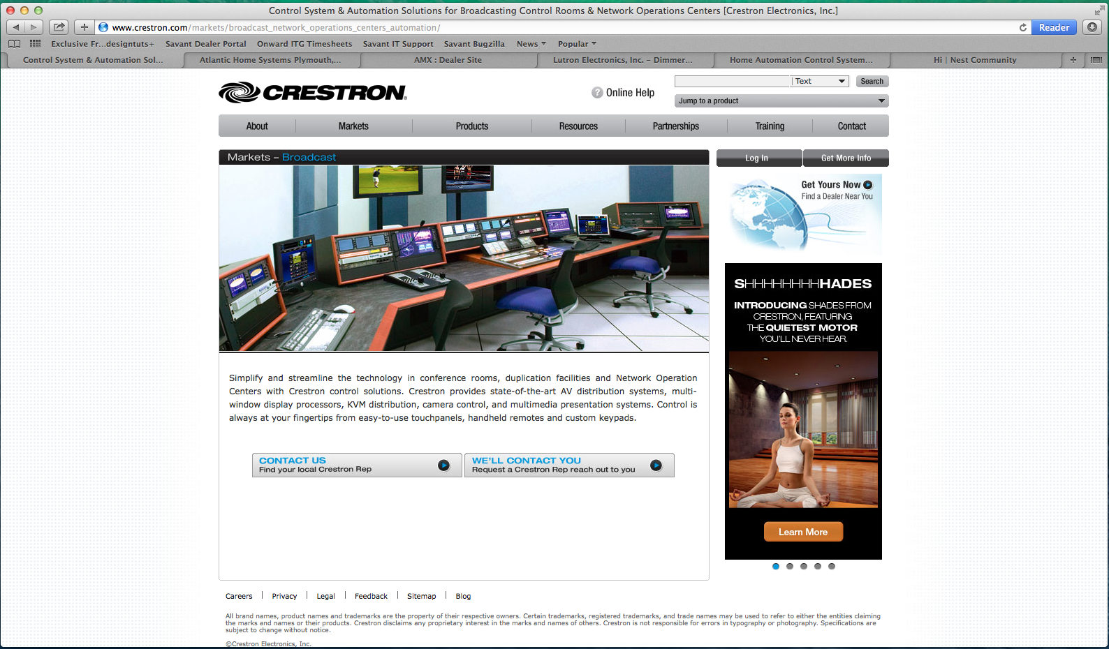

7. Inconsistent experience. Crestron’s Experience Center has a completely different look but internally is still just brochureware. The contact links are mailto: methods vs. a form for making appointments. This shift in template at a 2nd level isn’t expected and is somewhat jarring when stumbled upon.

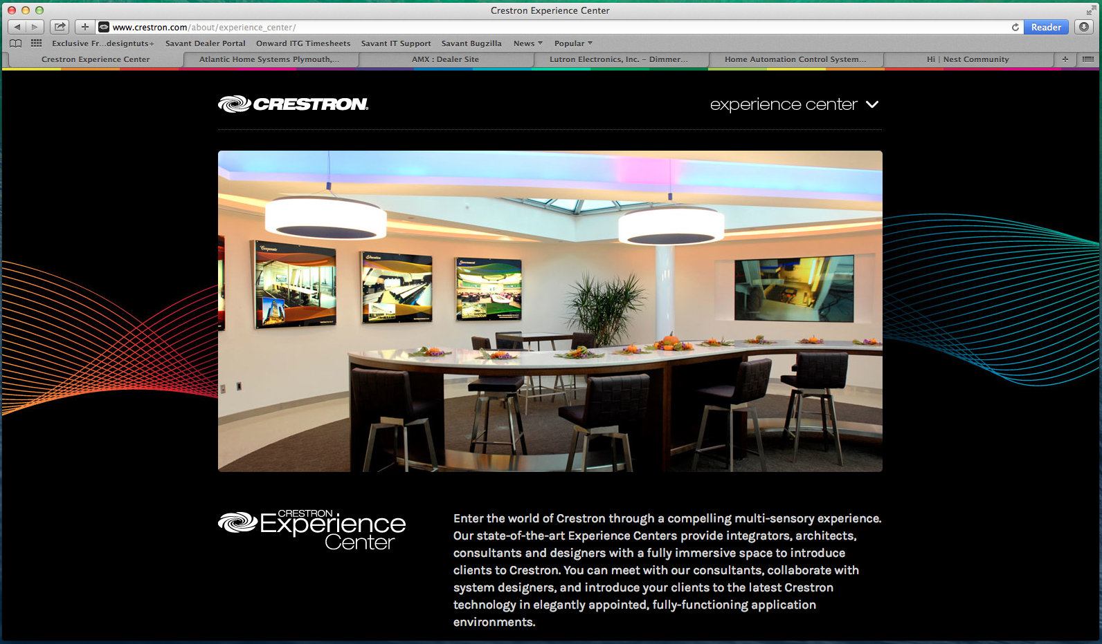

8. Product pages lack imagination. Product landing, and product detail pages appear very standard and are pretty boring as a result. Note the house ads in the right column that eats up space probably better served by featuring the product, as well as providing jump off points to the user during a browse-n-buying flow.
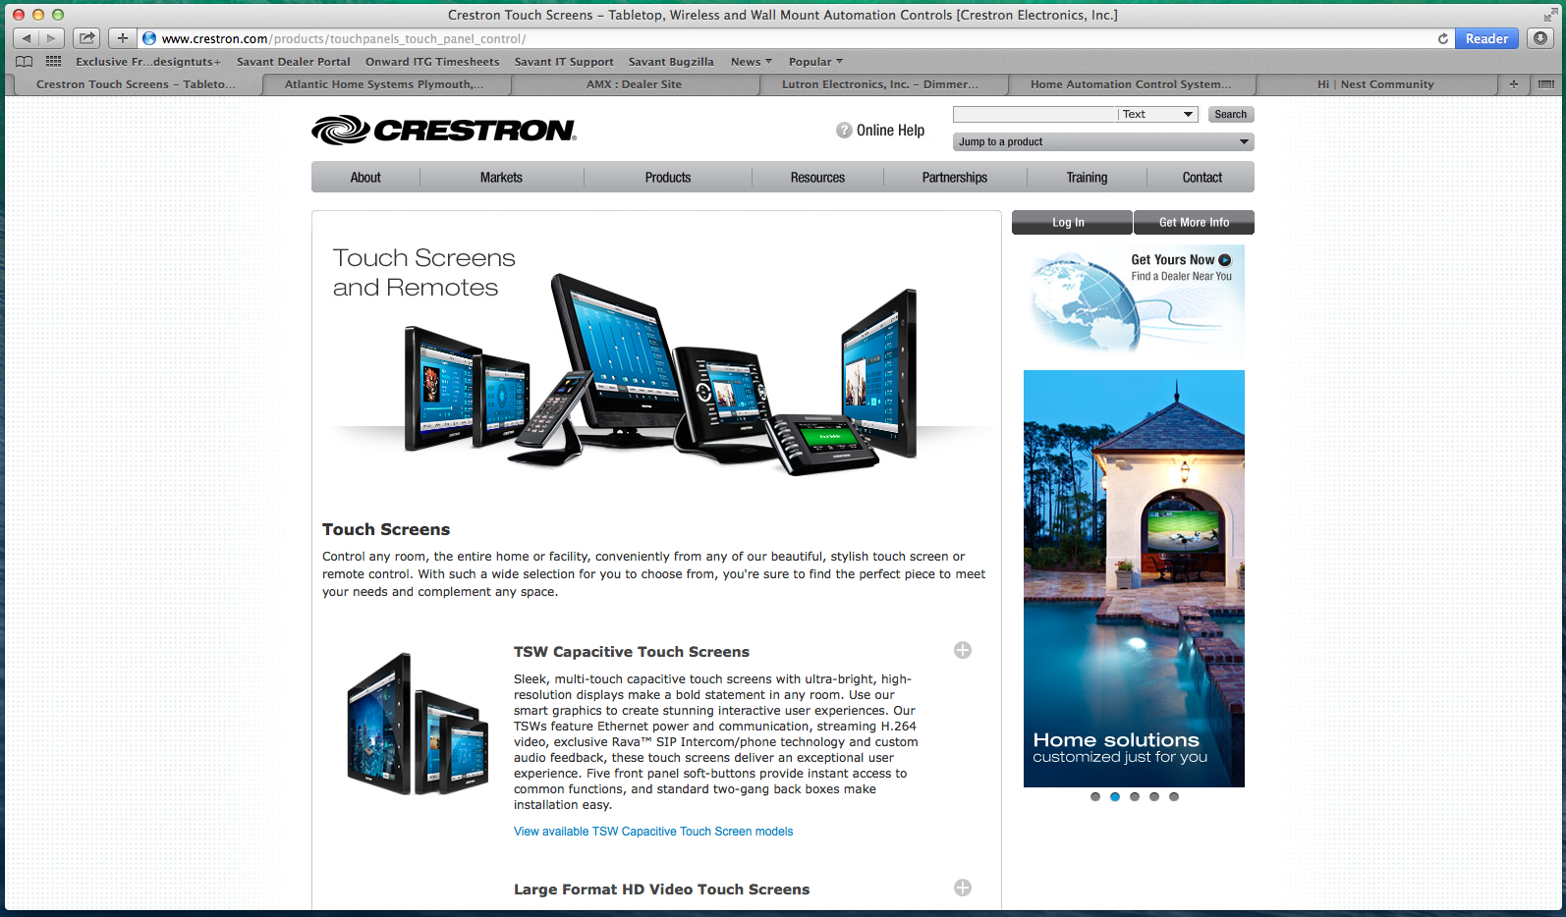

A not pretty tab set on the product detail page; product image shots are decent however.
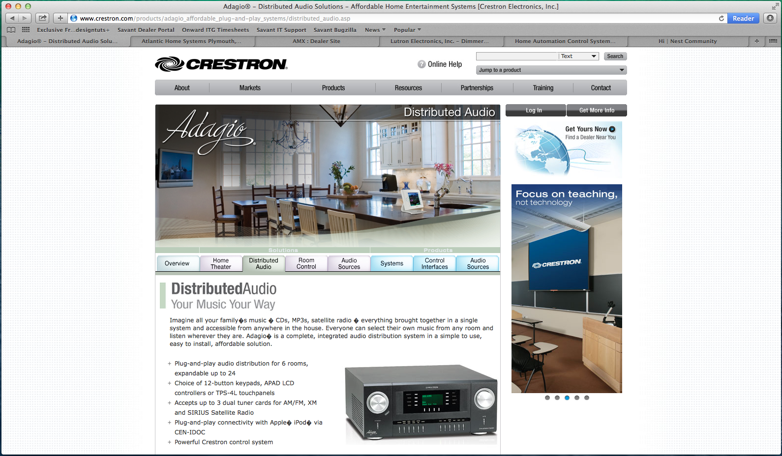

9. Case studies are done only as downloadable PDFs This was probably a choice made to expedite sales handouts but forcing the user to download vs. view doesnt seem to serve them well as the products are indeed the “shiny bauble” that sells to consumers.
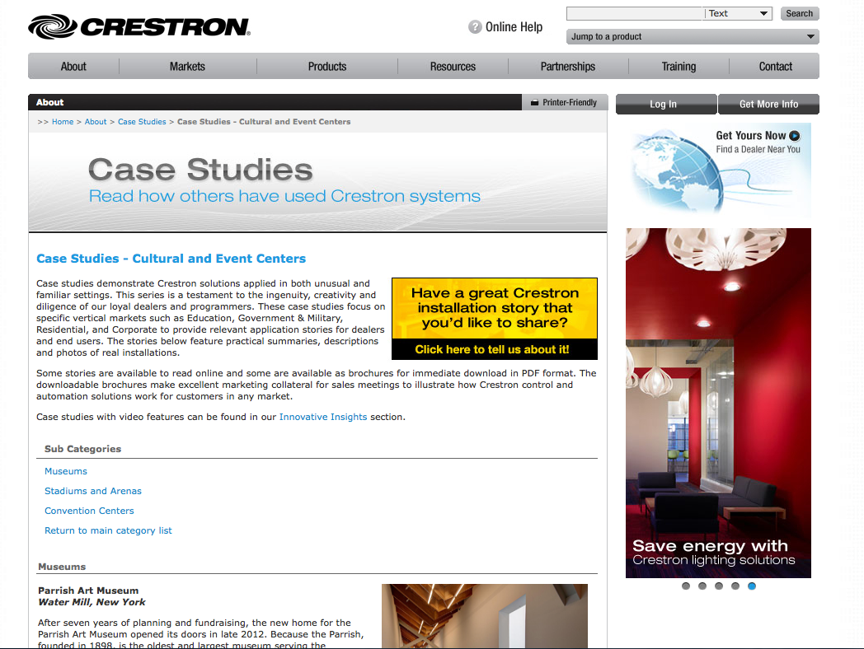

10. Inconsistent social sharing and social networking - There’s a blog that appears to be updated quarterly (which itself begs to reason for having one), and sharing tool bars are located in different incarnations on the home page, at the blog article level, on footers and right columns as stop-gap implementations.

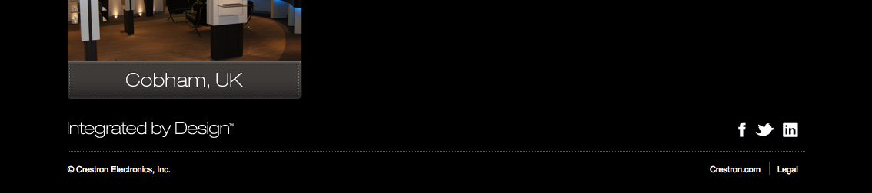
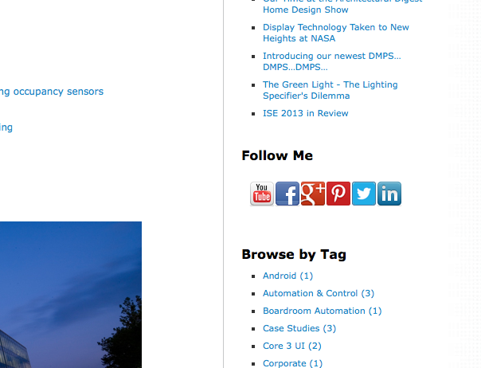

AMX - www.amx/trade.asp
“Dealer Site”
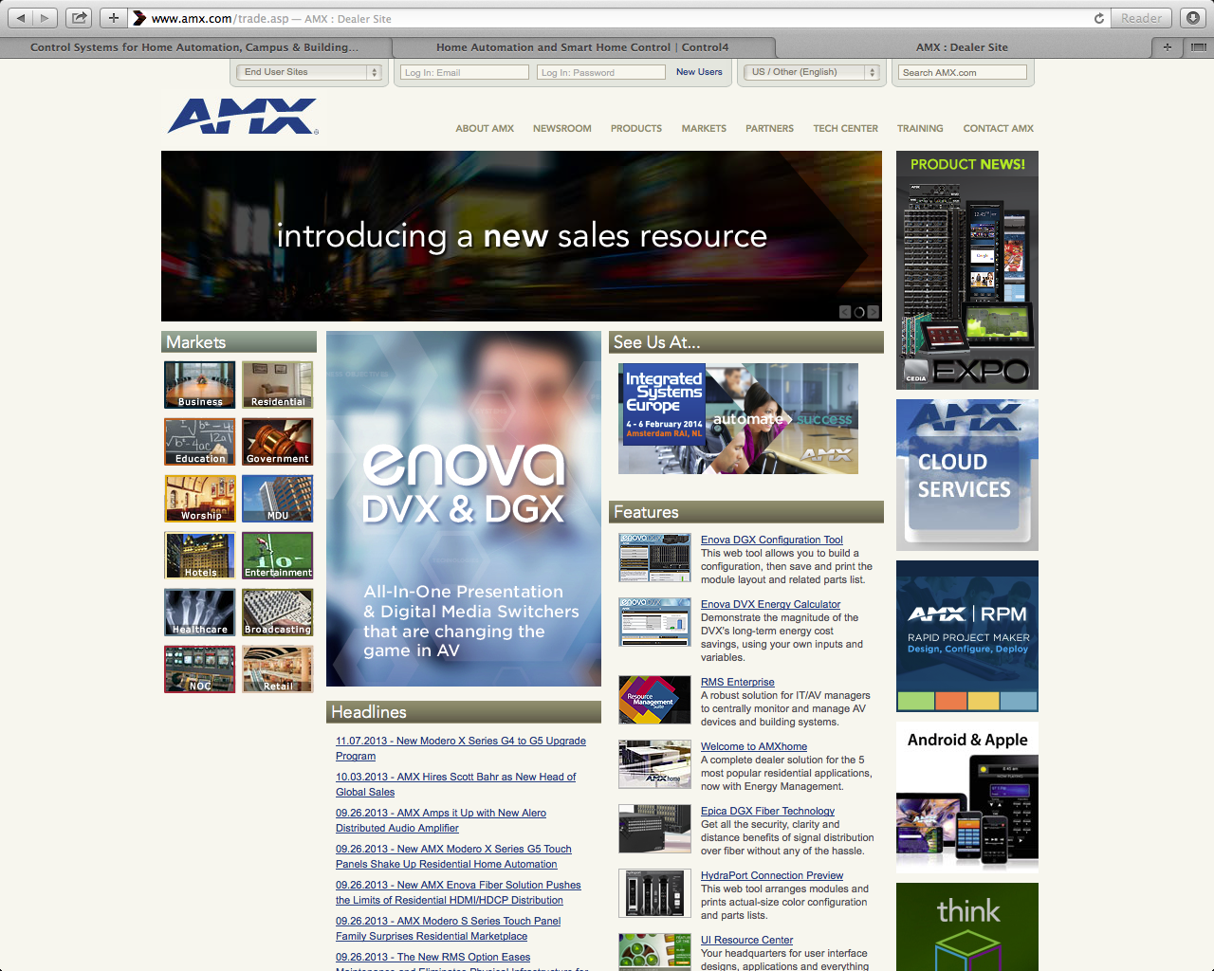

Primary: Introducing a new sales resource designed to help you sell more. Visit AMX.com”
CTA: N/a
Secondary: Seems to be a mix of product specific messaging within the carousel

General Observations
AMX’s site appears geared to the commercial dealer/installer. The site is dense, crammed, lacking white space, and busy with imagery, and there’s no clear call-to-action or value proposition so much as a clutter of text, imagery, and. animation for animation’s sake. In fact here’s little marketese language, and no consumer level content to speak of as most of the copy speaks to a technical/insider audience that already understands their offering and potentially knows what they’re looking for. Some additional notes:

- Site designed as fixed-width, center-aligned 1024w-viewable.
- Does not appear mobile or tablet scalable
- No mentions of device integrations to Apple or Android or third-party reselling so much as exclusively AMX products

Content
There’s a lot of content in the way of basic marketing pages but the writing is not remarkable or original. At a glance much of it seems like filler copy that was written on the fly, even in areas like their case studies, or specific pages that markets the company services and product details, much of it reads as boilerplate that is dense and technical as opposed to marketing.

Design
The templated design of the site feels static, antiquated, blocky, and canned. It’s for the most part consistent but generic, and at times it’s difficult knowing what page or section you’re actually in because there’s little variation from page to page. Styling is intentionally muted and stylistically benign, so much so that much of what’s here fades into the background of the page enough to go unnoticed. Color choice seems to be dring tone -- A series of muted beiges, tans, and organic earth tones that do little to convey a sense of brand dynamism or excitement. There’s also plenty of small and inconsistent typographical usage throughout the site doesn’t encourage or compel users wanting to read.
Takeaways - Strengths/Weaknesses
Overall, not a lot here we want to take from vs. use as guidance about what not to do.
1. AMX market segment landing page lacks excitement. This feels like any page, from any site. The actual case studies are sublimated to the right column that’s traditionally ad space.
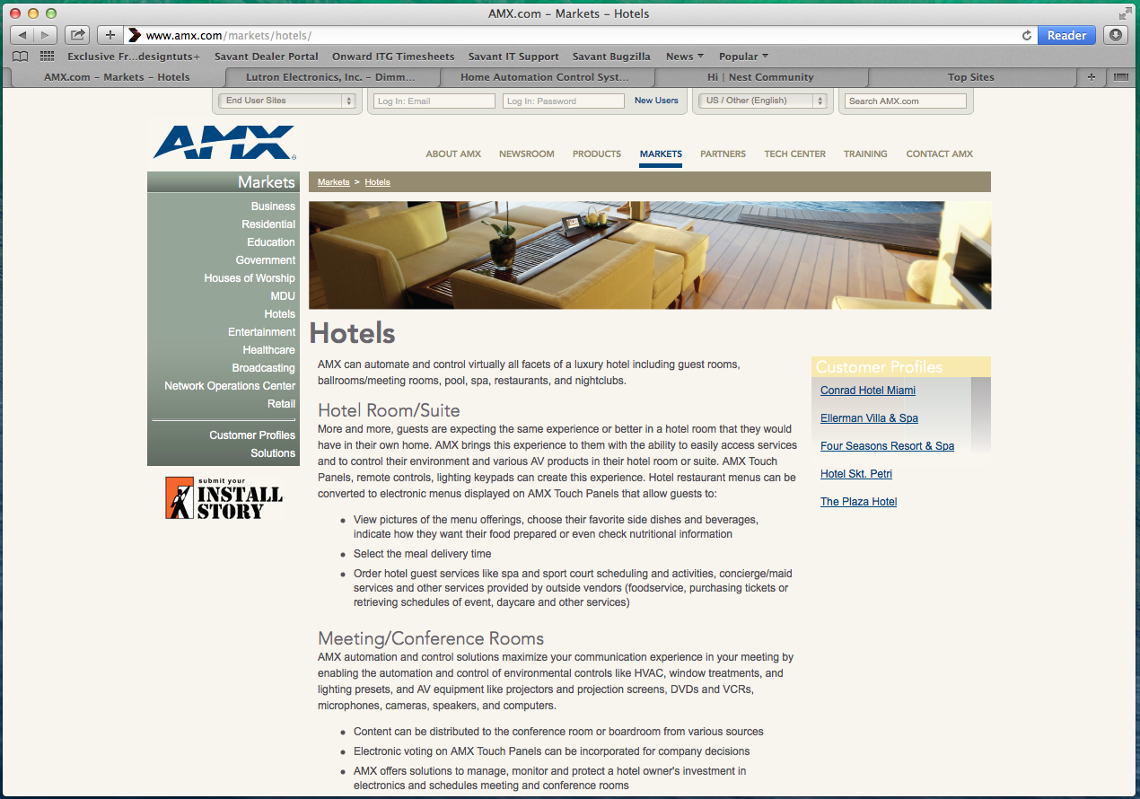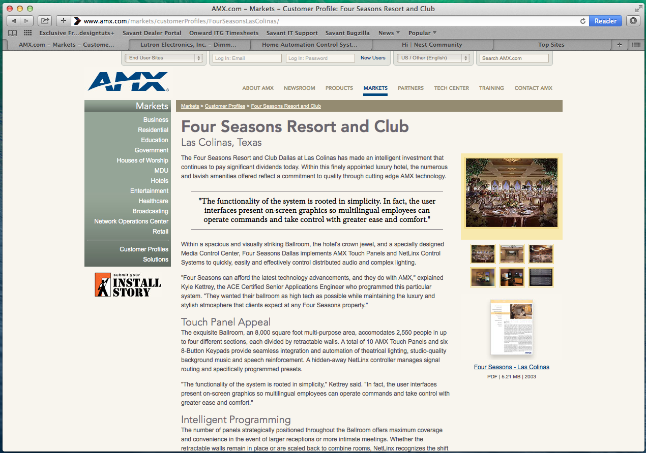

2. AMX makes ample use of mediocre to poor stock art; color usage comes off as arbitrary and circusy.
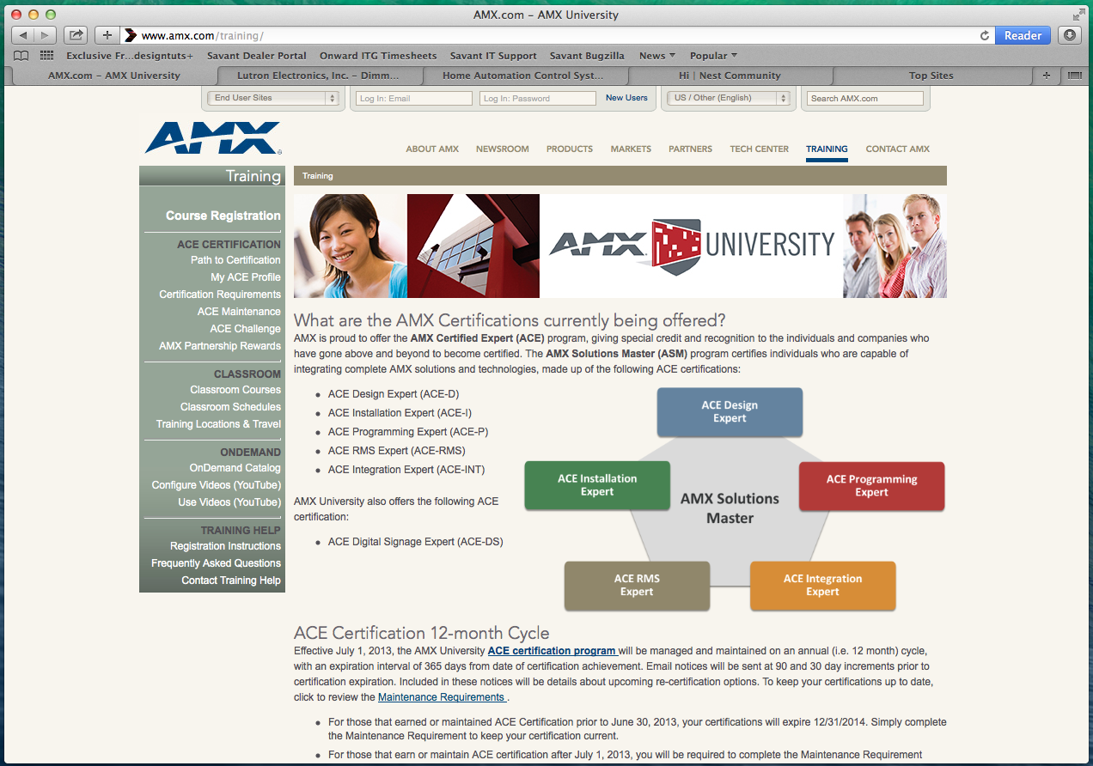
3. AMX’s site has products set up like a commerce site but with actual ability to “buy now.” No obvious store functionality for unlogged visitors, but may be available after logging in as a dealer.
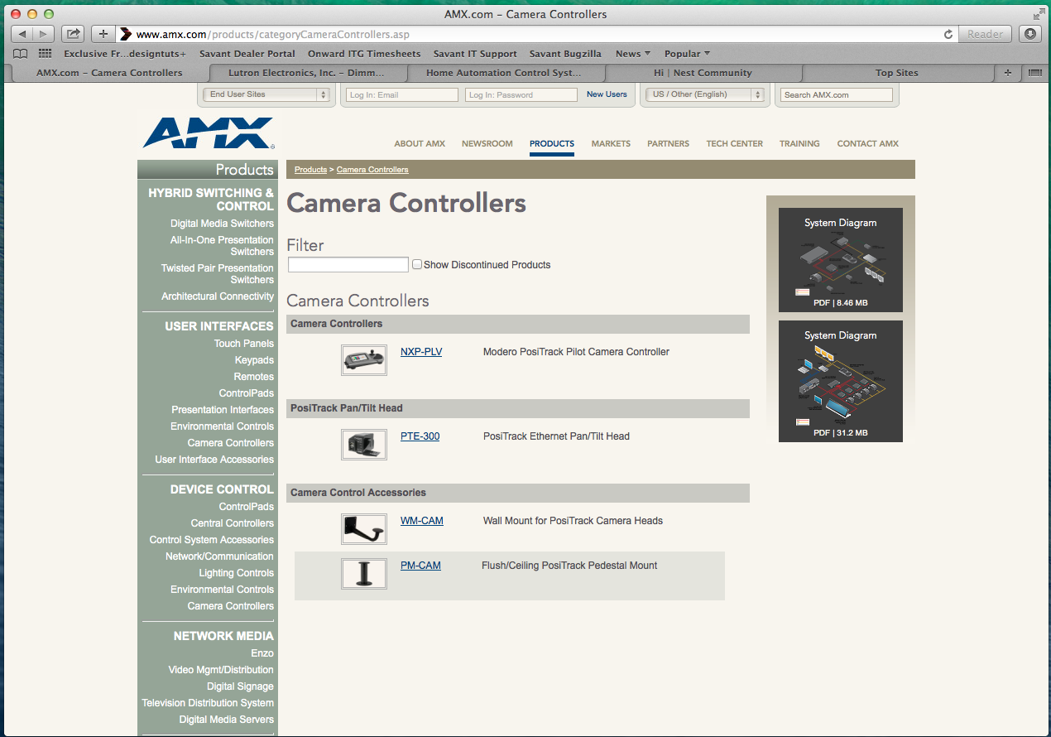

A product detail page from AMR
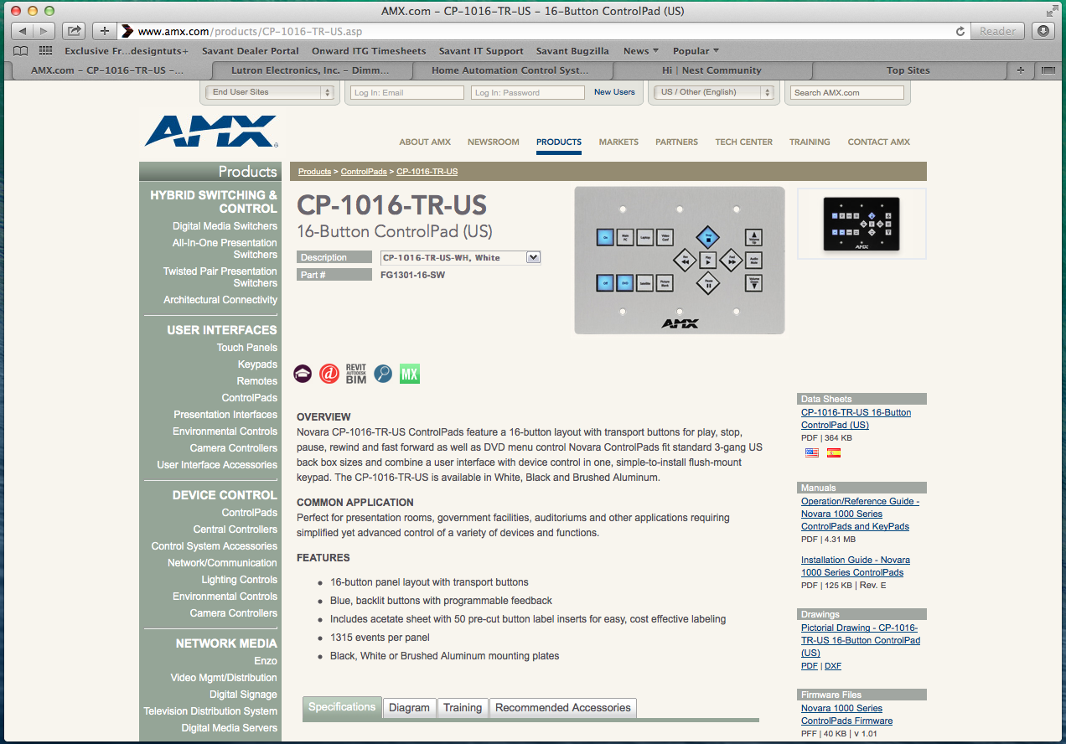

Lutron http://www.lutron.com
“Lutron Electronics, Inc. - Dimmers And Lighting Controls”
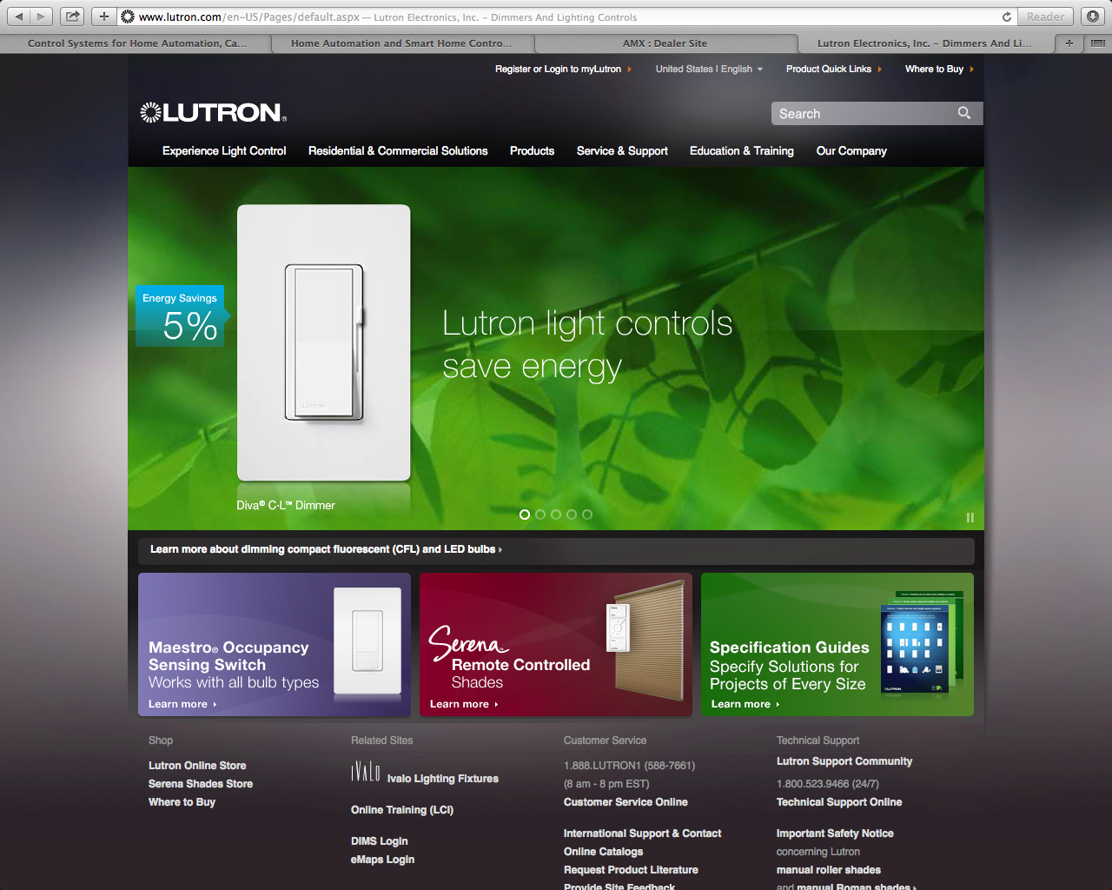

Primary: Lutron light controls saves energy
CTA: See for yourself, learn more
Secondary: Similar message on saving energy but with other products they offer.

General Observations
Lutron’s site is modern, clean, and succinct. They don’t bother with unnecessary bloat and understand that it’s the end result that people are interested in -- What it Means (WIM)-- that sells their products. From the home page down through the site, there’s a good balance of content to page, and cross-linking to related content without it appearing convoluted. Animations, embedded video, and direct interaction help tie together the product offering as a whole as something touchable, approachable, within reach for varied levels of consumers or installers. On this last point, there’s no mention of divisions between buyer types like the other sites that have been reviewed.
Content
The content is professionally written and it shows. There’s a clear and concise tone to all their marketing content and messaging that is direct and easy to understand, e.g. “Lutron sensors save energy”. When things have to be explained, such as “Why Lutron?” the page weight is kept nomical at about 2-2.5 screens in length, and the typographical styling of dark text and light backgrounds makes it all very readable.
Design
They chose a high-contrast design that makes the site highly readable and interesting to review. The use of bold color and sharp imagery, smooth animations for transitions in their home page carousel, and use of in-page interactivity further compliments the design style, and makes the user feel a part of the site vs. an outsite observer of their products.

Takeaways - Strengths/Weaknesses

1. Use of black matte, full-width imagery, and high contrast type make the pages readable. The choice provides a good “pop” as well as visual appeal.
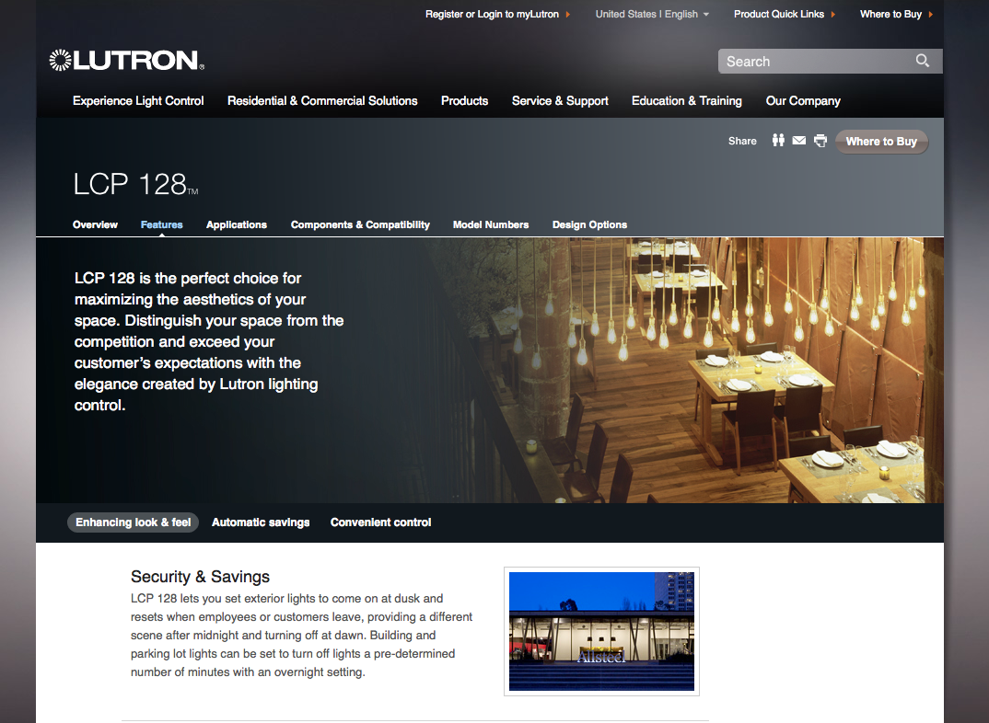

2. Mega-menus fold down from the main nav and aren’t best-of-breed in that they seem organized but bloated at first glance, as if the groupings of content couldn’t be organized in a better way.
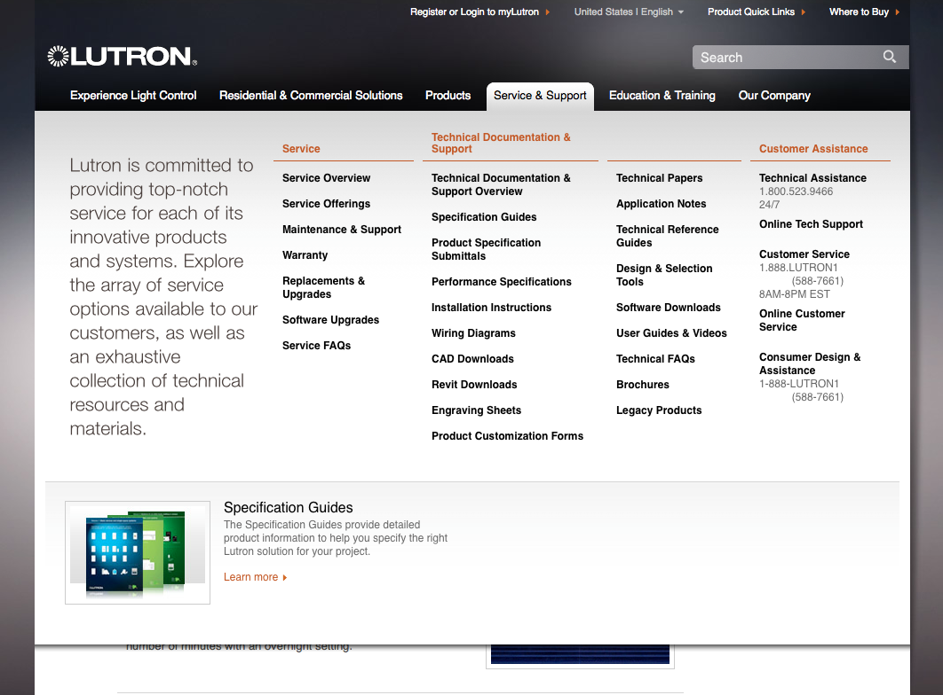

3. Locator menu folds down from the top, bold color used to as “coding” to identify key sections
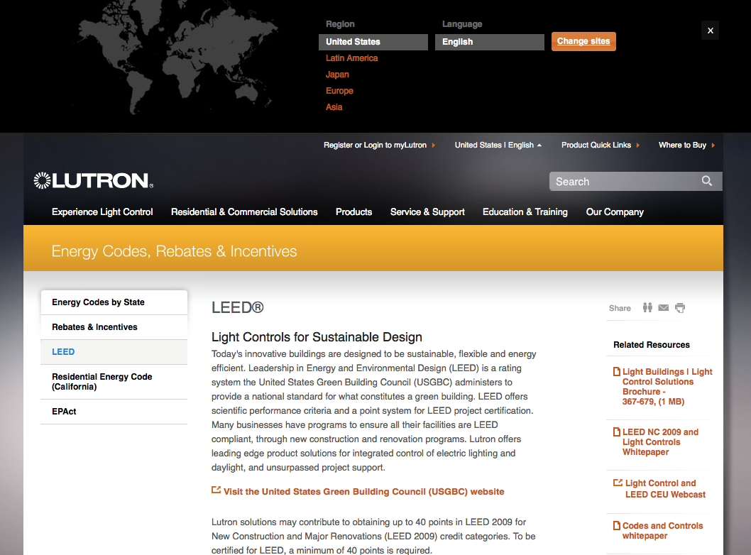
4. Pages are interactive to the user with immediate facts, figures, and visuals to show end-user benefits of the system.
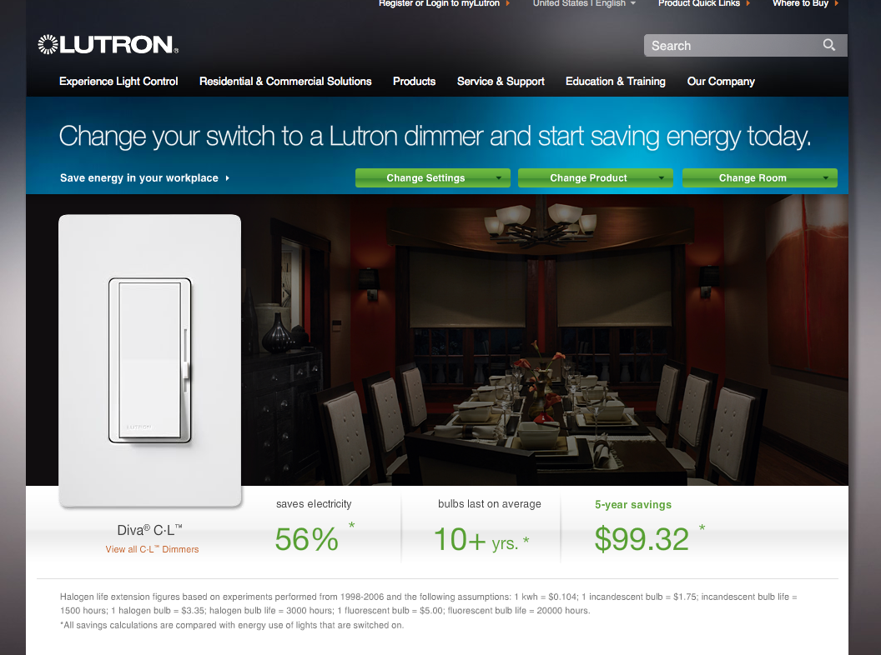

5. Product detail landing pages are clean, clear, visually appealing, and break with convention.
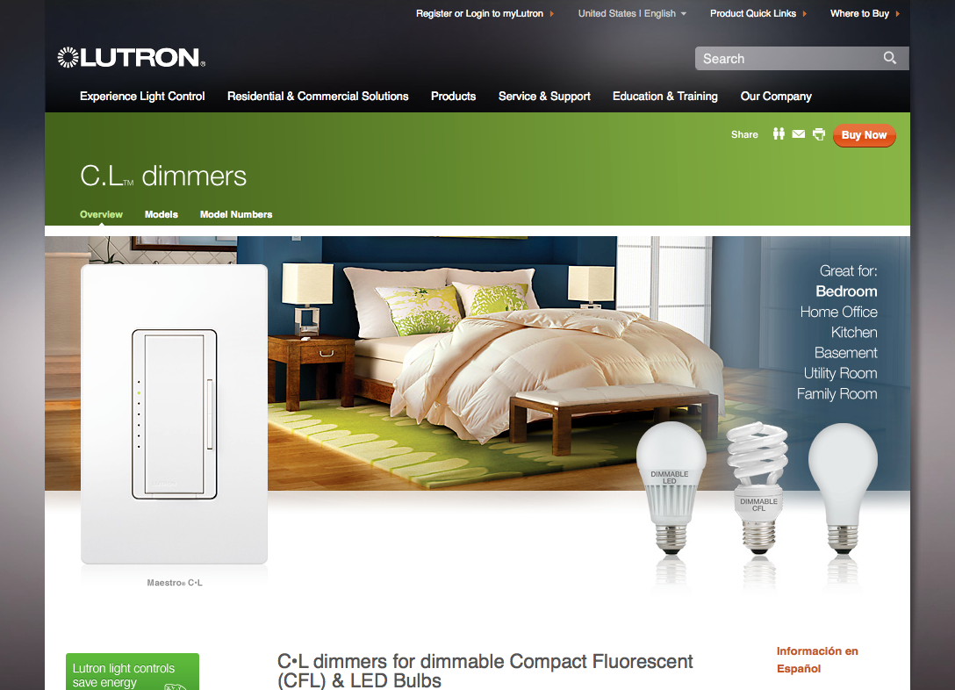
Nest http://www.nest.com
“Home | Nest”
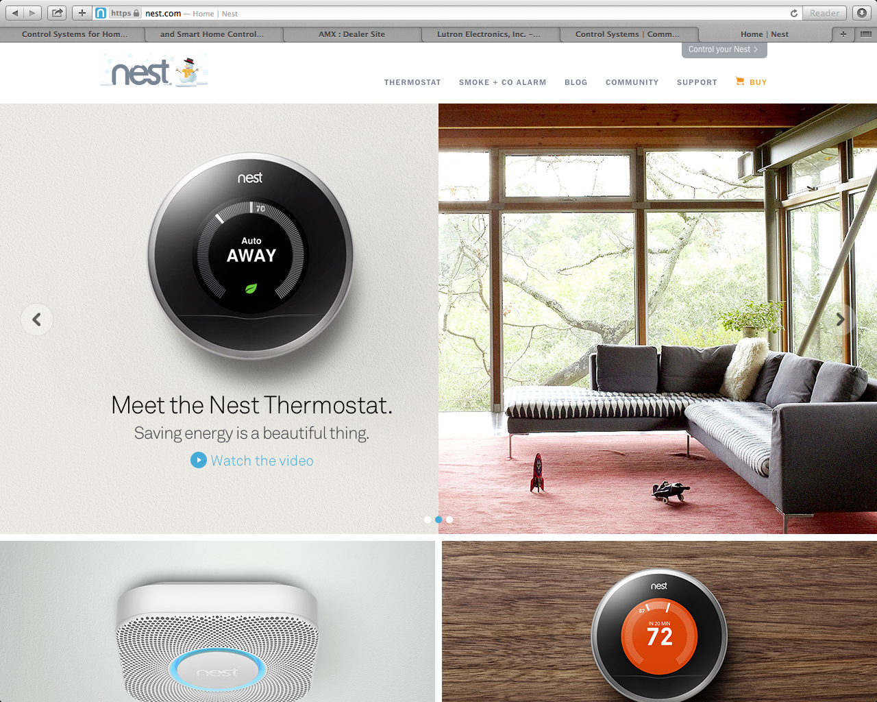

Primary: Meet Nest Protect. We reinvented the smoke and carbon monoxide alarm
CTA: Watch the video
Secondary: Meet the Nest Thermostat. Saving Energy is a beautiful thing.

General Observations
Nest personifies many of the qualities discussed as being desirable: It’s lean and crispy, employs a high-quality “flat” aesthetic, uses clear messaging, and an end-user value proposition that’s direct and to the point. Nest’s site utilizes a unique design and methods of interaction that bolsters these attributes, making for a potent offering that markets, interacts, and compels conversion behaviors. Other noteworthy features:

- The site does a good job of conveying the economy, and ease of installation (Worth noting for our own DIY needs)
- Sub-areas such as the Thermostat section, features a “one page” design coupled with in-page interactivity, e.g. on Day 2, Day 7 the “hands” movie demos how the unit works and then swaps to a method that allows the user/viewer to turn the dial.
- Social sharing is persistently in the footer, in their product reviews in context to social sharing, and also can be found sprinkled throughout the site at differing levels - press, genericized testimonials. There’s also a blog that’s kept current and fresh.

Takeaways - Strengths/Weaknesses

1. Nest makes use of multiple dimensions in the layout - (Below) A home page promotional window shade, folds down (or optionally up) while still maintaining the integrity of the home page. Transitional animations make the page feel active when toggling this effect.
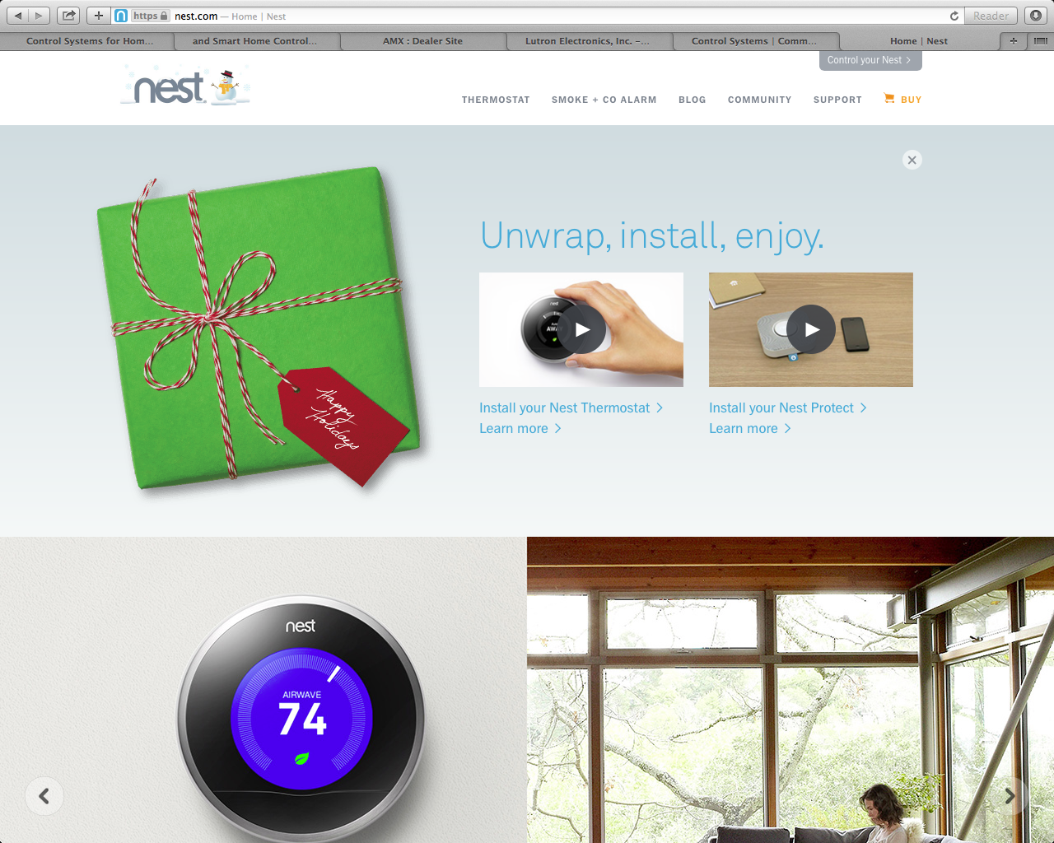

2. Nest works Interactivity directly into the page. A movie demo plays when this is in focus showing how it operates, then swaps to allow the viewing user to turn the dial themselves. 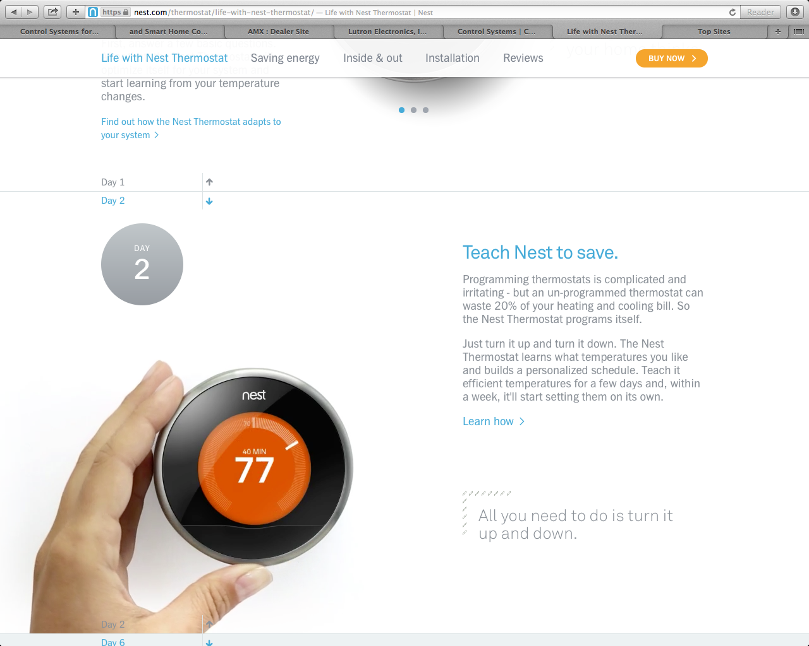
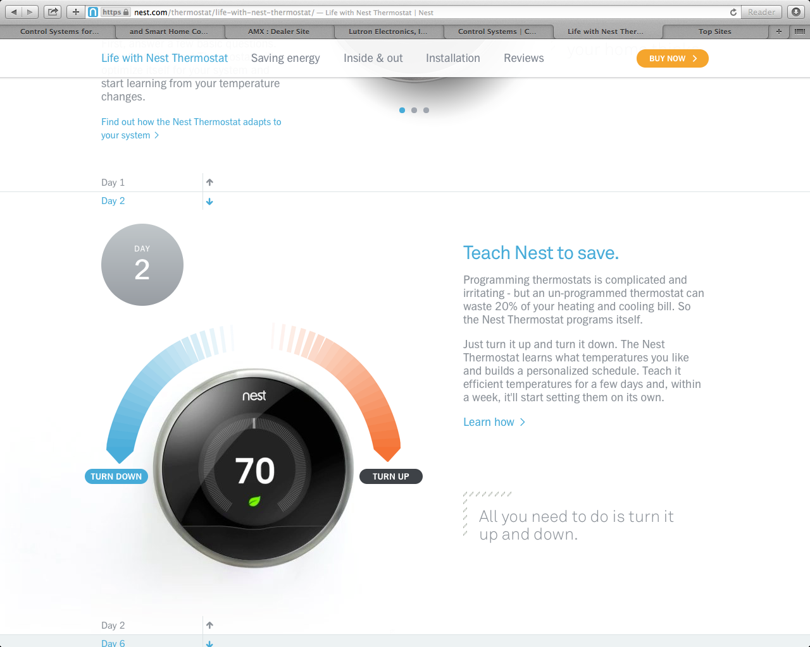

3. Nest balances trust-building with direct access to the product. Through good structure of static text teasing that segue to “learn more” jump links, and “buy now” buttons all above-the-fold, you never feel overwhelmed. Nest doesn’t hard sell so much as soft-sell using an explore and discover approach.
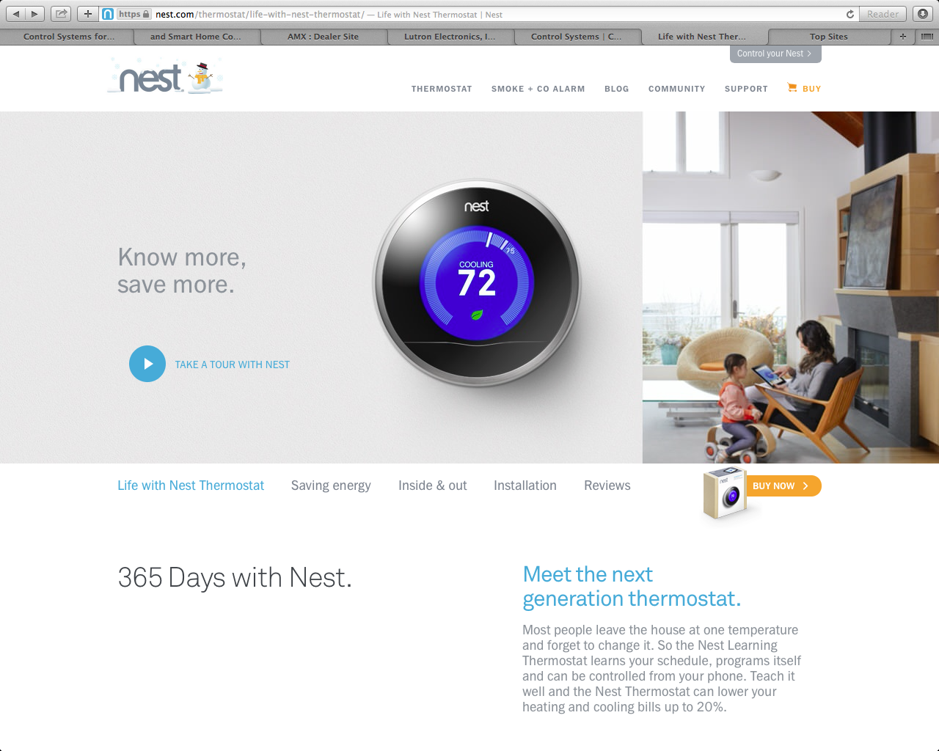

4. Nest employs Social Networking integration throughout the experience. Social networking and sharing options work best when displayed in contexts (after watching a movie, after reading a review or article) that makes sense.
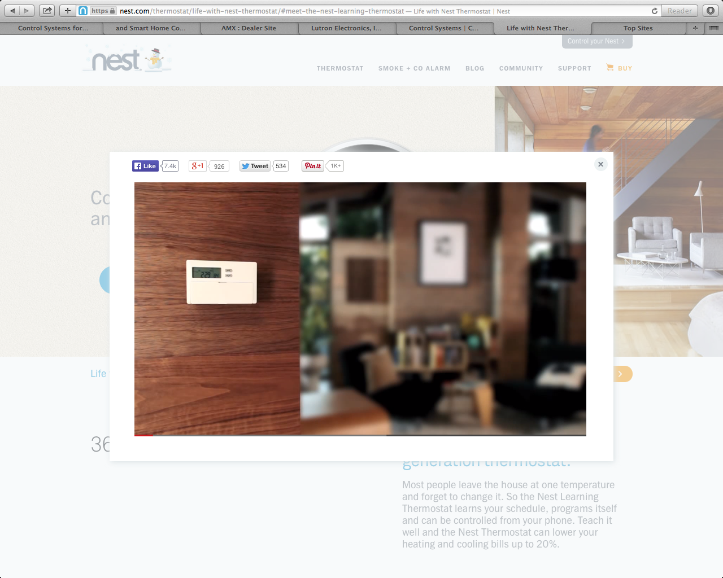

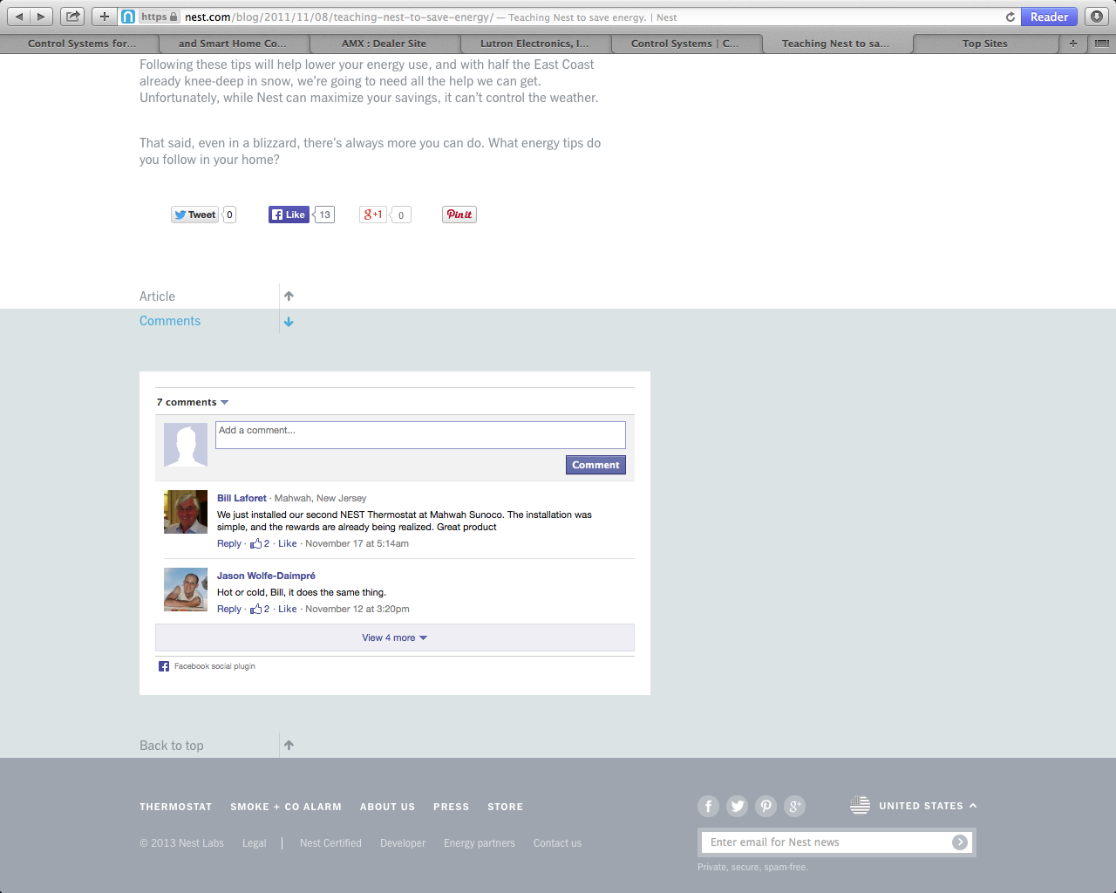

5. Nest does a good job of humanizing the product. They understand that they can leverage their employees as “people behind the products” who step forward in their blog, their product sheets or white papers to act as “ambassadeurs” of their brand and product
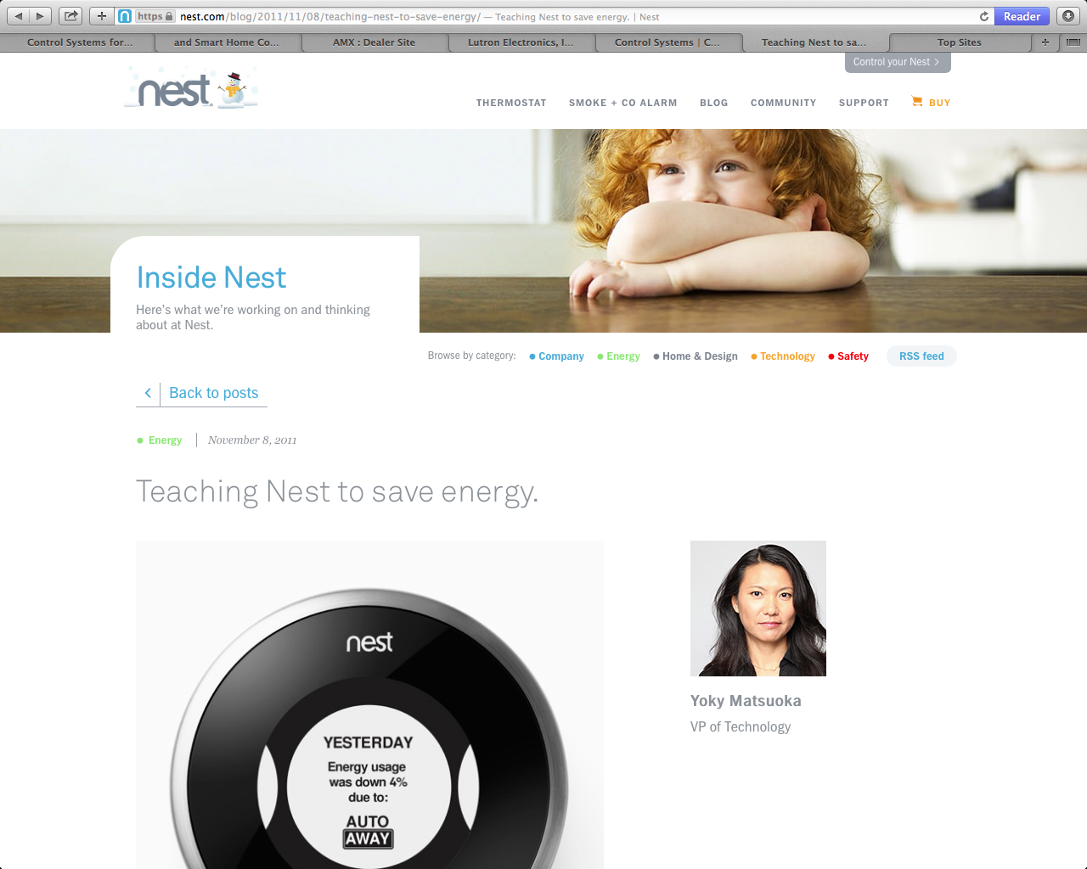

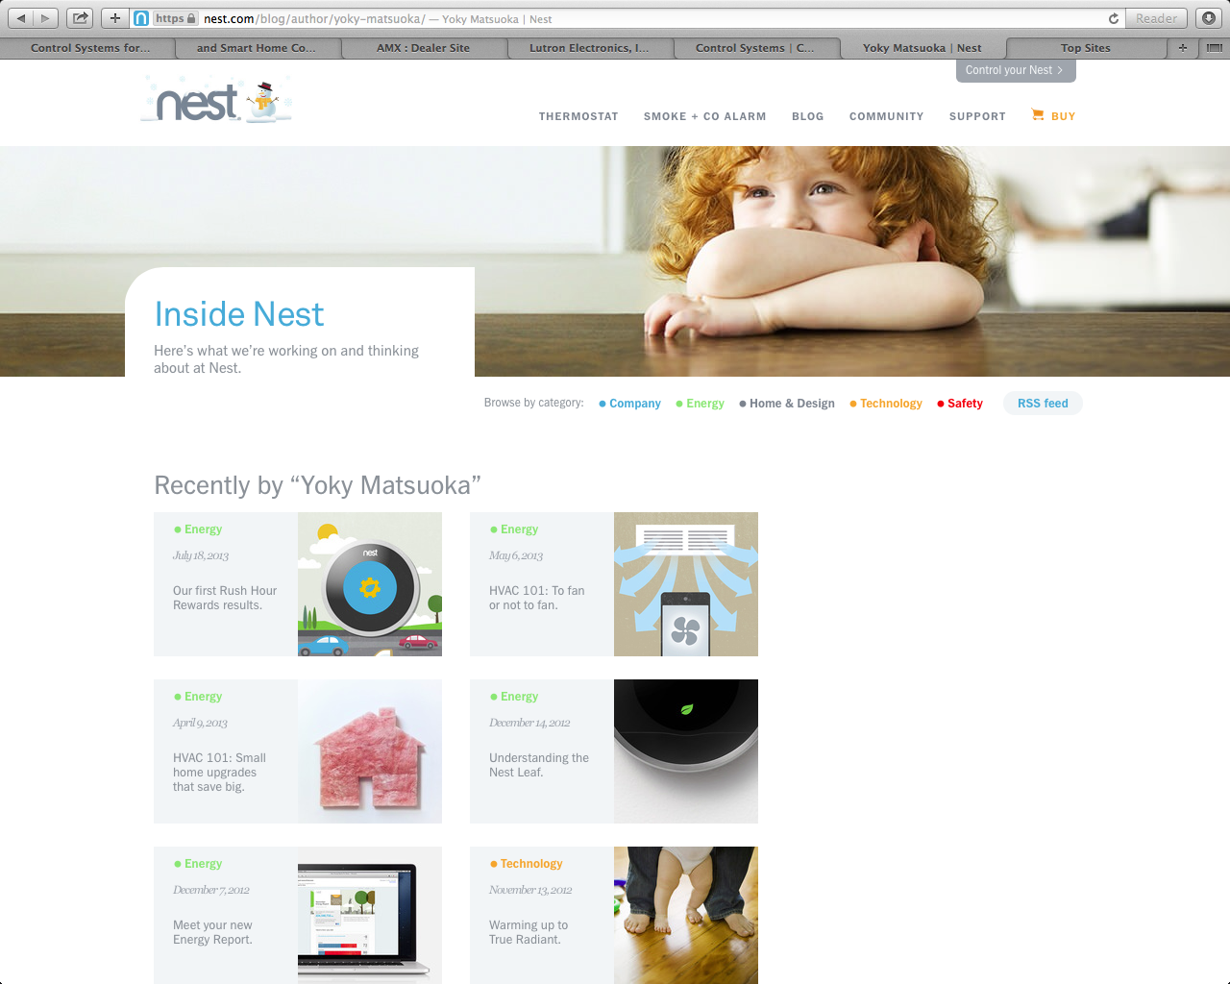

6. Nest uses “breakout design” styles, subtle and tasteful animations, transitions, and easing effects, to make the site seem app-like, lively, and magazine-like. (Type as art, talking bubbles fade and animate to new content, the blog talks about upcoming releases, updates, and events)
